Tab 1

Energy and Civilization Notes
Christopher Kalitin

1. Energy and Society

“Energy is the only universal currency.”

Drops of water erode rock with low power over lots of time to get high total energy.

Natural selection works to increase the total biological mass of the system. And energy flux.

Willhelm Ostwald:
First man to expand the second law of energetics to all actions. Free energies are the only ones this can be applied to.

His energy imperative:
“Do not waste any energy, make it useful.”

Ronald Fox: “A refinement of cultural mechanisms has occurred with every refinement of energy flux coupling.”

Eric Blair, George Orwell, 1937 2nd chapter of the road to something pier:
“In the metabolism of the western world, the coal miner is second in importance only to the man who plows the soil.”

Again, Orwell same book:
“For this reason the actual process by which coal is extracted is well worth watching if you get the chance and are willing to take the trouble.”

Leslie white: cultural development proportional to energy use.

Feynman:
“It is important to stress that in physics today we have no knowledge of what energy is. We do not have a picture that energy comes in little blobs of definite amount.”

“All matter is energy at rest.” tf?

First nuclear reactor in 1943. Photosynthesis was understood in the 50s.

Electromagnetic energy goes from the sun to the Earth. Broad spectrum.

Solar energy: 30% reflected by clouds, 20% absorbed by atmosphere, 50% absorbed by oceans and continents, converted to heat, then re radiated into space.

Formation and reactions of molecules requires liquid water. Lower bound. Temperatures and pressures required to destabilise amino acids and breakdown proteins form the upper bound.

Apparently we’re right on the inner edge of the habitable zone. Closer, runaway greenhouse effect.

Animal energy use is limited by muscle volume.

Kinetic energy of wind and water harnessed into other forms. Capabilities restricted by prevailing wind and ocean currents.

This steered expeditions to the Caribbean!! Also restricted Spanish trading ships discovering Hawaii despite sailing from Mexico to the Philippines from 1565 to 1825.

Combustion: chemical energy of plants into thermal energy.

Firing bricks? What is this manufacturing process? God damn this is the kind of book I love, amazing anecdotes every minute.

Many gates were required to release the potential of energy. Education, predictable legal rules, transparent economic rules, capital availability, and etc.

Extremely difficult to predict timing and flow of energy after gates are opened.

Every form of energy can be turned into thermal energy. Is this more fundamental somehow than other ways of saying this?

Potential for useful work diminishes as you move along conversion chains. Entropy is associated with this loss of useful energy.

Burning wood leads to random motions of air particles, entropy.

Loss of complexity, more disorder, and homogeneity.

Life causes heterogeneity and complexity. Anti entropy, but why exactly?

Joule showed the equivalence between heat and work.

Watt wanted a standard way to charge for his steam turbines. He used horsepower.

Pre Hispanic people of the basin of Mexico are plenary of prickly pairs. 80% water, <10% carbohydrates, 2% proteins. 5kg would be required each day to get these micronutrients for a women, compared to 650g if eating ground corn (comparing energy).

Heat and work are equivalent! One newton of force over a meter is equivalent to heating 4.2g of water 1 degree Celsius. Feels counter intuitive.

8-11 MJ required for humans everyday, 10MJ can be supplied by a kg of whole wheat bread.

Watt assumed 3 feet per second pulling 180 pounds to get a horse power.

Small cars produce 50kW.

Power density of sustainable natural tree growth in temperate climates is 2% the power density of traditional urban heating, cooking, manufacturing. Cities required 30x larger areas to get energy. Limited growth.

Photosynthesis converts <0.5% of incoming solar radiation into new phytomass.

Poplars, eucalyptus, and pines were the fastest growing species. Produced around 10t per hectare. In good climates. Per year presumably.

18 GJ per ton of wood. Wow. But 0.6 W per square meter on net.

18,000,000,000 J / 365d / 24h / 60m / 60s / 100m / 100m = 0.57 J/s

Charcoal was the only pre industrial smokeless fuel preferred for indoor heating by all early civilizations.

Charcoal to wood ratio was 1:5. Mass ratio? Charcoal is 29 GJ per ton. 30% efficient process.

Cities relying on charcoal would require an area 100x their size to supply the charcoal.

Energy returns must always be greater than one. Get more energy from a harvest than it took to sow the seeds.

Energy intensity is energy required per unit mass of output.

Pig iron in large blast furnaces requires <10% energy intensity than pre industrial hot charcoal techniques.

Pig iron is an interesting topic to google. High carbon content since charcoal was being used as the fuel or something. There’s a fascinating manufacturing process there.

Candles convert 0.01% of the chemical energy tallow or wax into light. Edison’s light bulbs in the 1880s were 10x more efficient.

1900s:
Coal plants 10% efficient, bulbs turn no more than 1% electricity into light, 0.1% of coal's chemical energy appeared as light.

Combined cycle plants use hot gas exiting a turbine to produce steam for a steam turbine. 60% efficient. Fluorescent lights and LEDs are around 15% efficient. 9% of energy in natural gas ends up as light. 90x gain since the late 1880s.

I love these books, the anecdotes and connections to other ideas from first principles, just talked to grok for a while about candles and everything else to do with it: https://grok.com/share/cc1672b5-4c76-4572-a894-662594c54e32

Stanley Jevons, English economist, 1835-1882. More efficient steam engines led to an increase in coal consumption.

In countries with high per capita energy use, “at saturation”, Jevons paradox is weaker. Marginal increase in consumption decreases, unfortunately. Why?

The energy ratio of agriculture is better for traditional methods. But not when looking only at human labour energy input. When taking into account electricity, gas, etc. modern farming is less energy efficient.

The energy ratio of agriculture is only possible because of the equivalence of forms of energy.

Energy return on energy invested. EROI. Energy ratio?
Coal: 10-80
Oil and gas: 10-100+
Large Wind: <10-20
PV Solar: <2
Modern biofuels: <1.15, on net they’re closer to 0.9-1

Smokeless coal was a big factor in British dominance of maritime transport in the 1800s. France and Germany didnt have coal of similar quality.

Wheat contains up to 14% protein and 70% complex starchy carbohydrates. We can’t eat straw because of its composition. Not all energy is the same.

Many high energy foods contain no proteins or lipids, which are required for humans.

The point is many other factors matter. You need saws and axes for tree wood, branches and sticks are easier to get.

Best gas furnaces are 97% efficient. Is the other 3% still heat just going somewhere else?

Burning straw requires frequent stoking? Large pieces of wood can burn unattended.

Net energy cost of human labour is the best number thats been come up with. Energy use above existential need that must be satisfied for survival.

Net efficiency of steady aerobic work is about 20%. Average every use in humans is 2 MJ/day. So 400 KJ/day useful output.

A couple minute repeat in the recording here.

Lots of labour is mental. Hard thinking isn’t too energy intensive compared to physical labour. But learning requires lots of time. Net incremental energy isn’t too high, but over the entire time surivial takes a lot of energy.

2. Energy in Prehistory

The first hominids date to about 4 million years ago. Homosapiens to ~190k year ago.

Only 10k years ago our ancestors began a sedentary existence based on domestication of plants and animals.

3.5 million years ago, hominids began eating a diet more rich in C (presumably carbon).

Bipedalism is stuructrally improbable but very consequential. Can be traced to 7m years ago.

Breaking bones is more likely and apparent old age bone health issues. Also requires split second thinking in the controlled falling movement called walking.

Not clear why bipedalism occurred. Looking big doesn’t make a difference to cheetahs. Etc.

Human walking costs about 70% less energy than quadrupedal and bipedal walking in chimpazees.

Hand dexterity and tool use and carrying could be developed.

Each finger is represented differently in the brain, each can be used individually.

Brain volumes have been increasing for over 150M years.

Early wooden tools were only preserved in anoxic environments. Bogs?

Cobble based stone tools are the earliest. Small hammer stones with edges, flakes. Easier butchering.

Earliest date accepted for stone tools at time of writing was 3.3M years ago in Kenya.

In 1948, a nearly complete spear was found inside an elephant skeleton in Germany. Dated to the last interglacial period. 150-125k years ago.

Bladelits, made from heat treated stone to make composite tools, dated to 71k years ago.

1.9 million years ago is when cooked food is dated to.

2-10% of woods energy ends up as useful heat.

For the 200k people that lived 20k years ago, 20-30k tons of wood required to cook all the food. Which is 10E-8 of standing pre agricultural wood phytomass.

Population de situ of foragers, minima was 1 per 100km^2. Global mean of 25 per 100km^2. Density of foragers was lower than animals capable of digesting cellulose phytomass.

All foragers were omnivorous. Killing animals targeted far less food than plant gathering, and it required more energy.

Herbivores consume 1-2% of net primary productivity in some forests. 50-60% in some tropical grasslands. 5-10% describes most grazing.

<30% of ingested phytomass is digested. 1-2% converted into zoamass. (Spell?)

Hunting in Papua New Guinea tropical forests had a 25% energy return.

Grasslands have lower energy per unit area as tropical forests but it’s more easily collectible in the form of nutritious seeds and fruits, or large concentrated patches of large starchy roots and tubers.

Unlike in forests, animals in grasslands can grow to be dry large sizes and move in herds.

Humans sweat better than any other mammal, we can chase animals to exhaustion.

Brazil Nuts have high lipid content and hence 37 MJ/kg.

Even as humans migrated north, they kept their ability to sweat. This meant they were better at hunting.

Hunting large animals led to dexterity, technology, and market encephalization (increased brain size?).

Quadrupeds can only breathe once per locomotor cycle.

Optimal quadruped speed is structurally determined, while humans can run at many speeds.

Horses lose 100g/m2 of skin, humans are 500. Camels are 250. 550-625 W of heat loss. Wow

Natives of New Mexico ran down deer. Diurnal high temperature chasing machines.

Communal hunting brought the greatest rewards, huge incentive for cooperation.

Head smashed in buffalo jump, UNESCO site where animals were ran off cliffs for 5700 years. Alberta.

Hunting could have eliminated much of the mega fauna of the late Palaeolithic. >50kg body mass.

Megatons of animal mass would have had to of been hunted. 2 million animals. Natural (climate and vegetation change) and anthropogenic (hunting and fire) were the likely causes of the end of the mega fauna.

“All preagricultural societies were omnivorous. They did not have the luxury of ingnoring any available food resource.”

Seeds were preferred among gatherers, high energy and protein and easy to collect.

Wild grass seeds have as much energy as wheat!!

Low fat in wild meat, so low energy density.

A mammoth was worth 50 deer.

Some foragers apparently gathered for only a few hours every day.

Unpalatable plant tissues would have to be eaten, many famines, infant deaths including infanticide.

Smaller or boreal ground mammals in tropical or rai forests had net energy losses. The large animals could be 30-40x.

Some foraging societies had high complexity. Permanent settlements, high population density, large scale food storage, social stratification, rituals, crop cultivation. Stone houses and firing clay in Moravian less region.

Large aquatic animals had the highest energy returns in foraging. When scandinavians ran out of large land mammals, they turned to porpoise and whales and collected shell fish.

Salmon has 15% far content, and hence 3x higher energy density than cod at 9.1 MJ/kg.

The Inuit had >2000x energy return killing migrating baleen whales.

This meant seasonal energy flows. Storage required. Caching in permafrost, drying and smoking and berries and meats, storage in oil, making sausages and nut meal and flours.

“The quest for the manipulation of an ever larger share of solar energy flows set the societies on the road to higher complexity.”

Alaskan settlements reached up to 2600 people.

Blubber is 36 MJ/kg. Vitamin C from this too.

Salmon runs in the pacific north west too. You could just scoop them onto boats. Great return.

This is what allowed for artistic endeavours, totem poles.

We can’t fully reconstruct paleolithic diet, plant remains don’t last long.

C3 and C4 pathways for phytomass: primary photosynthetic pathway using a 3 carbon compound, 3-phosphogylcerate. Coker climates. And C4 which includes another step to reduce photorespiration.

Agriculture has no single cause but arose from many interdependent interactions.

Cropping evolved independently on 3 continents in at least 7 locations. Cold climate of the early Holocene made itincentiviized, low carbon in atmosphere too.

“Fundamentally, crop cultivation is an effort to ensure an adequate food supply and hence agricultures origins can be fully explained as yet another instance of an energy inperitive.”

Diminishing returns of gathering and hunting.

Early farming required higher end energy inputs than foraging. But it supported higher population density.

Sourthern lavant was thought to be the origin of agriculture. More recent research suggests it was the upper reaches of Tigris and Euphrates.

Agriculture started on the edges.

Domestication of plants and animals proceeded concurrently.

Radiocarbon dating of material from early Neolithic sites show democracy diffusion radiating didnt her northern Lavant. 0.6-1.1km / year.

Many similarities in techniques, all trying to minimise energy expenditure.

Slashing or burning to prepare fields for planting. Plant nitrogen lost in combustion but mineral nutrients enriched the soil. From where?

Men did heavy work of cutting down trees for fencing when animals were an issue. Women weeded and harvested.

South American agriculture left terra pretta. 2 meters of dark soils. Charred wood, crop residues, human waste, bones.

Hurons in North America cultivated beans in 35-60 year rotations. 10-20 people per hectare.

11-15x energy return for small grains. 20-40 for root crops, bananas, and corn. Up to 70 for some roots and legumes.

Moderately productive agriculture supported population density 10x higher than the best foraging.

Animal husbandry is prey conservation. Differed harvest. Bigger animals prefer, or higher growth rates for animals like sheep and goats. They convert grass into meat, milk, and blood with little human energy.

Nomadic grazing dominated most of the world. Hemmed in by more productive farmers and dependent on bartering.

Some nomads had invasions and conquests of agricultural societies.

Single herders could control hundreds of animals.

Blood harvesting. Jugular, harvesting 2-4 L per every 5-6 weeks.

During drouts, 80 cattle was required for a family of 5-6. 13-16 animal per capita.

0.8-2.2 people per square km. East Africa.

3. Traditional Farming

500-2000 kg per hectare of grains, 2k in most intensive traditional agriculture.

Shifts to more productive agriculture methods requires higher animal and human labour input. High activation energy and potentially negative initial returns.

“The villages of Carolingian Europe were overpopulated and their grain supplies were chronically inadequate.”
How’d that work out?

Manchuria was settled by the Chinese in the 1800s. Difficult to do agriculture.

Java has higher pppulstion density and agricultural productivity than the smaller Indonesian islands.

Farming was supposedly renewable, but energy stocks were often depleted. You had to burn a field or forest first.

Poor practices lowered soil fertility, caused erosion or desertification, abandonment.

More advanced farming required higher labour input. Wells, canals, tools, etc.

Legumous crops fix nitrogen, rotate with cereals, now you have higher output.

What are terraces and raised fields?

Grain milling and oil seed pressing were the impetus to use water and wind power.

4 big jumps in agriculture: more efficient animal labour, irrigations, fertilisation, crop rotation and multi cropping.

Early on, you get an energy surplus.

Some tools diffused early and were unchanged for millenia. Sickle and flail. Others diffused after a long time and went under a lot of improvement, like iron mole borred plow and seed drill.

“Without sickle and plow there would be no cathedrals or no European voyages of discovery.”

Foraging required nearly constant high mobility, farming was more seasonal.

Leg bending strength declined with farming, visible in bones over 33k years.

Marcus Cato, 2nd century BC. Compendium of farming advice. “See that you carry out all farm operations betimes. For this is the way with farming. If you are late doing one thing, you will be late doing everything.”

Everywhere, farming cycle began with plowing. Sumerian cuneiform and Egyptian glyphs have symbols for plows.

Plowing is better than hoeing. Breaks up soil, uproots weeds, loosened well airated ground for seedlings.

Greek Roman and other early plows were just sticks. Later with metal on the end.

Mole boards turned out the plowed soil and weeds. For some reason this is improtsnt. They sttted as wood planks, then became curve pieces of metal, first in China. Then diffusion.

Mesopotamia, 1300 BC, first seed drills. Europeans started using them in northern Italy in the. 1600s, widespread in the 1800s.

1.5m long cutting edge sickles documented in Rome.

In China, shoulder beams were used to transport manure.

Oil was extracted from seeds by manual or animal presses. Cane juice too, sweet.

The Incas planted potatoes at high elevations and steep surfaces. Corn lower down.

Corn exponential!!

Grains don’t spoil when they contain <14.5% water in well ventilated areas?

Proteins mainly provide essential amino acids to build and repair body tissues.

All animal foods and mushrooms supply perfect proteins (good proportions). Most grains are missing most of one or most of most of the essential amino acids.

Two proteins in wheat are unique. Monomerit gluten proteins (glyodin) are viscous and polymerit gluten proteins (glutenin) are elastic. When combined with water they form a gluten complex that is sufficiently elastic to allow dough to rise, and strong enough to retain CO2 bubbles from yeast. Without these proteins, we’d have no bread.

Low yields and poor storage meant a third to a half of medieval grain crops had to be set aside for seeds next year. With greater harvests this fell to <15%.

Most cereals are milled before consumption, and lose most of the whole grains mass.

The husk layer makes up 20% of rice grain mass. Removing it gives you brown rice. Removing various levels of the brown layer gives you white rice.

Fungi, insects, and rodents reduced edible grain total by up to >10%.

Wheat spread from the Middle East to all continents because it does well in many climates (semi deserts and rainy temperate zones) and in many soils so long as they’re well drained.

Rice is semi aquatic and grows in partially flooded fields until harvest.

Rigged wet fields, germinating seeds in nurseries and transplanting seedlings and providing subsidiary irrigation all mean labour requirements are far higher.

Potatoes grow best in cook summers with abundant rain.

In northern regions the ground would thaw by April, but they waited to plant until may to avoid killing frosts. Only about 3 months until the return of killing frosts.

Many days in winter in north China were devoted to maintaining and extending irrigation.

Old Chinese proverb on soaring labour requirements when little time to harvest:
“When both the millet and the wheat are yellow ripe, even the spinning girls have to come out to help.”

Chinese water buffalo worked around a third of the year doing planting, grading, harvest, field prep.

In dry land farming, animal labour was capable of replacing many human tasks. In wet farming, hoeing was replaced by deep plowing by water buffalo.

Irrigation and fertilisation removed two key constraints. Water and nutrients. and Growing many crops allowed for more resiliency and higher output.

Chinese peasant sayings:
“Whether there is a harvest depends on water. How big it is depends on fertiliser.”

Draft animals were also a source of manure and the method of distribution.

Domestication resulted in many breeds. Weights over an order. Small donkeys at 100kg, 1000kg for horses.

Tractive force of working animals is roughly proportional to weight.

Horses can output 2 kW at peak for brief moments. At these times they can draft 35% body weight. Most animals in sustained conditions can draft 15% body weight.

Horses usually deliver 550-800W.

Heavy clay soils were much harder to plow than lightly sandy soils.

Double head yolk was the first one used. Best on short necked animals. Long wooden beam harness. Also, a pair must always be harnessed together. Greater power output.

Plowing often required ~150kg of force.

Unlike cattle, horses fronts are heavier than their rears. 3:2. It can take better advantage of inertia?

Horses can work in most fields except heavy wet soils at a speed of 1m/s. 30% faster than oxen. 2 hour long pulls.

Dorsal yolk, chest strap. Roman harness discovered. Design spread across Eurasia. Reached Italy by the fifth century, Northern Europe 3 centuries later. Chinese invention.

Not sure im interested in writing an analysis of Horse yolks. Collar harness came next.

Weight limit of 500kg put on horse drawn wagons by theodosian code, 439 AD.

Horses required grain. Oxen could eat straw.

Horses' hooves are soft and insensitive. Horse shoes are a natural next step. Traction and endurance.

Greeks put horse hooves in leather sandles with straw.

Horses work 8-10 hours per day vs 4-6 for cattle and they live longer.

Horses and oxen and cattle start working around 3-4 years. Horses continue for 15-20 years.

Horses have a ligament going down the legs that allow locking of the leg without engaging muscles. Standing is extremely low energy. Resting or dozing while standing.

Humans hoeing would require 100-200 hours to relate a hectare for planting cereals. Ox drawn wooden plow meant ~30 hours.

Animals ran wells, lower wells could be dug.

North America and Europe, horses took up to a third of agricultural area. In China, cattle were sued as they could survive on straw.

Cattle could require the area that could feed one person, for 3-5 people of work. Horses weren’t as good.

Manure recycling with animals.

Humans peak at 150W, horses 1kW. Half our car.

Wheat required 15-30 cm of rain. Irrigation in semi arid regions was required, with 0-25 cm of rain.

Seasonal water shortages in monsoonal Central Asia. Punjab and north China plain.

Oldest widespread water lifting method was the counterpoise lift. Recognisable on the Babylonian Cylinder seal, from 2000 BC. Went to Egypt then China in 500 BC.

Long wooden lever with a bucket. A single man could raise 3 cubic meters of water 2-2.5 m per hour.

Archimedes screw was more energy demanding and only worked for 25-30 cm.

Single blind folded animal walking in a circular path. Wells <10m deep, at a rate of 8 m3 per hour.

A man would need 3 months to lift half the water requirement of a hectare of wheat one meter. Extremely high labour cost.

What is the cost of different types of energy? Energy return for human agriculture is higher than machine agriculture, how do you find the price here?

Only well established governments that could shift resources over lots of space could build large irrigation systems. Years or decades of delayed return.

Kilo tonnes of water!

Water ladder treading returns about 30x its energy investment from peasants.

Continuous agriculture would require draining flood waters. Emperor Yu, ~2200 BC. Grand prolonged quest to drain flood waters are the reason he is remembered.

CO2 and atmospheric water are the majority of plant matter. Other elements are needed for photosynthesis, depending on amount named micro or macronutrients.

Iron, copper, sulfur, silica, calcium and the macro. 3 micronutrients: Nitrogen, phosphorus, potassium. NPK.

1 ton harvest in a hectare of wheat, removed 1kg calcium and magnesium. 2.5kg sulfur, 4kg potassium, 4.5kg phosphorus, 20kg nitrogen.

The others are replenished with rain, dust, weathering, crop residues. Nitrogen isn’t.

Nitrogen can be readded by recycling crop radiuses (eg straw), organic matter (yea), leguminous crops.

In wooded regions, straws and stalks were burned, nitrogen loss.

Chinese cities, 70-80% of human waste recycled. 1650s, nearly all of modern day tokyo's waste was recycled.

1869, Paris was generating 4.2 megatons of nitrogen per year. 40% horse manure, 25% human. Late 1800s, about half of the cities waste was collected and turned into ammonium sulphate.

Most manures are 0.5% nitrogen.

Flinders field got 10-40 T per hectare of various fertiliser substances. Mostly 10.

Organic fertiliser with the highest nitrogen content is guano. 15% at best. Sea bird droppings preserved in dry islands off the Peruvian coast. Spaniards saw the Incas using it.

1824 exports to US, 1840 to England, 1850s rapid rise. 1872 exports ended.

Then, Chilean nitrates were the most valuable source of nitrogen.

Penned animals produced much more useful manure than grazing animals.

Full system loss of nitrogen commonly up to 66%.

Ancient Greeks and Romans did green manuring. Legumes. 100-300 kg of nitrogen fixed per hectare per year.

Food crop vs. Winter nitrogen crop. Crop rotation.

Higher population density incentivizes a food crop in winter. Decreases nitrogen. Short run you get more carbohydrates, long run you get less because you didn’t plant (edible) legumes.

1750-1880 when nitrogen fixing cover crops were adopted. 3x nitrogen fixation. Called another agricultural revolution.

Pests thrive on vast uniform plantings. Monocultures.

Variety of different types of crops reduces risk of harvest failure, discourages pests, better soil quality.

Bucks second survey of Chinese farming, 547 different crop rotation systems in 168 localities.

Leguminous grains were often linked with cereals. Green manures rotated with food crops.

Crop diffusions introduced new sources of carbohydrates and new micronutrient rice vegetables and fruits.

Cucumber was introduced to Europe overland through Persia, and by a maritime route.

The Americas brought potatoes, corn, tomatoes, and peppers. pineapple, cacao trees, vanilla.

4 primary early farming types?

Middle East/Egypt farming was the first large scale method. Rich soil and floods.

In the early 20th century, poor Egyptian farmers still have very high productivity for solar farmers (without aid of any fossil fuels).

East Asia. Methods survived till 1950s.

Mesoamerican societies did not do plowing or use draft animals.

19th century, export of European agriculture techniques and huge boom in American agriculture productivity.

Predynastic Egyptian agriculture tradable to 5000 BC. Finishing, emmer wheat, and domesticated sheep (first domesticated animal).

Old and new kingdoms used levies to control flood waters. Blocking drainage channels, subdividing reservoirs.

Counterpoise lifts were only good enough for small gardens, so no summer crops. Used wooden sickles.

Butser reconstruction of Egypt population density. 1.3 people per hectare of arable land in 2500 BC, 2.4 per hectare by the time Rome destroyed Carthage.

60% of Egypts cultivated land was in the Nile.

50% surplus of wheat for 5M people. Very important for Rome, as Egypt was their largest grain supplier. That’s how that damn free grain worked. https://youtu.be/CG6ZoMpgIqM?si=KYzytcfQWcc8qgLk

Egyptian agriculture stagnated after Rome. Even in the 19th century they cultivated half as much land as during Roman rule. But higher yields supported about the same number of people.

Imperial China underwent many periods of stagnation as well.

Before 300 BC no crop rotation or irrigation. Pigs domesticated 6000 BC. Clear evidence of manuring emerged only after 400 BC.

Many innovations: Iron mole board plows, collar harnesses for horses, seed drills, etc. Early Han dynasty.

Cast iron plows were perfected by 300 BC. Heavier but less friction than wood. Mass produced.

After 1400, techniques were stagnant. Expansion of area accounted for growth.

Nearly half of irrigation projects operating in 1900 were completed before 1500.

Unceasing maintenance, massive labour and capital allocation.

Eastern travellers were surprised by the accumulation and distribution of waste.

At least 10% of labour in traditional Chinese agriculture spent managing fertilisers.

Oil cakes (residues after pressing oils) have fairly high nitrogen content. Legumes and waste are mostly water.

Urea is the leading modern fertiliser. 46% synthetic nitrogen.

>90% was grains. 0.6 hectare average plots. 50% irrigated. 25% terraced. 5-10 mins from a farmhouse. One third owned an ox, less than that a water buffalo. Animals were fed little grain.

A late qing dynasty harvest of 1.5 t per hectare required 350 man hours and 250 animal hours.

Each kg of nitrogen gives at least 10 kg of grain.

Gross energy returns on corn were up to 40, but cornmeal was never popular in China.

Vegetarian diets, meats were extremely rare for special occasions.

1300 at 2.8 p/ha. 4.8 in 1600. Later, 5.5, higher than Java and 40% higher than the Indian mean. Nearly as high as Egypt when it used synthetic fertilisers.

Double cropping of rice and wheat in the most fertile areas got to 12-13 p/ha.

Mesoamericans domesticated many food and non food crops. Corn, tomatoes, cotton, etc. Cotton was first domesticated in the yucatan.

Mayan society expanded and thrives through 300 to 1000 AD. Complex society spanning a ton of land. Then, disintegration. Population from 3M in 800, to 100k by the time of the Spanish. Collapse maybe due to agricultural malpractice.

Upland Mayans built rock wall terraces that prevented erosion on slopes and conserved water. Elevated farm plots on lakes too. Ancient elevated plots still visible in satellite photography.

Irrigated lake land could yield 4x as much.

Raising 1 hectare of field 1.5m required 6000 man days. 2.5m3 per day. 30GJ total labour, you gained that back in just a single year.

This required long term central planning of labour. Mayans.

Romans rotated crops with legumes and distributed waste.

Because of the collar harness, horses started to replace oxen in richer parts of Europe. Sometime after the fall of Byzantium.

After hundreds of years to 1600, horses became the majority on all farms.

Extensive pastures favoured oxen. Extensive markets for trading favoured horses. Many other factors to give a complex outcome.

Medieval horses were similar to Roman horses. 13 hands in height. Breeding got some results later, with 16-17 hand heights.

Medieval farmers said horses were terrible in muddy clay soils. 19th century horses were not.

Cropping had to be intensified to provide for horses too.

14th century, epidemics and wars. Early 15th century, Europe had one third the population it did in the 13th century. Germany lost 40% of its peasants from 1618-1648.

Early 19th century over production induced depression?

<20kg average per capita annual meat consumption in Germany 1820. By 1900, 50kg.

Late 19th century European farming became a hybrid system. Animal labour and fossil energy.

Late 19th century, North America was the most labour efficient agriculture. Tons of innovation on the continent.

Charles Newbold, introduced a cast iron plow in 1797. Then an interchangeable part version by another man.

1830s, cast iron plows replaced by steel. John Deer commercialized production.

Better plows could be driven by many animals simultaneously and opened up the Canadian prairies. They could cut the grass land and open America's plains.

Grain reapers were patented in England in late 1700s and 1800s.

Practical large scale versions produced in the 1830s. Over 250k in use by the end of the civil war.

1858, first harvester patente by CW and WW Marsh. 2 men manually binding the cut grain. 1878, first successful twine bitter introduced. This meant everything needed for an automatic harvester was ready.

Twine binding harvesters were quickly surpassed by horse drawn combines. Stockton works in 1880s. By 1900, more than 500 hauser machines cut ⅔ of californias wheat.

The largest needed up to 40 horses and harvested a hectare in 40 minutes.

Early 1800, 80W farmer aided by 800W of two oxen. By the end, a California farmer by 18000W at his disposal. 30 horses. He became a controller of energy flows, not an energized of farm work.

England needed 150-170 hours for equivalent work of 9 hours in California. Central Valley of California.

Threshing was the only thing steam engines took from horses.

Growing feed for farm animals required a quarter of America's farmland. Tons of farmland was available. 1.5 hectares per capita.

1880s, American coal consumption surpassed wood combustion. Crude Oil was rising. Tools and shipments became dependent on fossil energy.

1910, America had 24.2 M farm horses and mules, only 1k small tractors.

1918, peak of 26.7M. 85k tractors! 30 MT of oats and corn required for animals. Working horses needed 4kg per day of hay. 30 MT of hay. Tens of mega hectares required.

End of 19th century, other parts of the world approached limits of energy availability. Subsistence diets and malnutrition and famines.

Fallow fields and inefficient use of animal labour remained in 19th century Europe. New methods don’t always mean previous methods are phased out.

Middle Ages, weather extremes don’t even prodive enough seeds for the next planting. Imagine.

Britain was at 500kg/hectare for over a thousand years. Land drainage and crop rotation increased it since 1600, then industry.

Roman human work to external work was 1-8, 1800 Europe, 1-15, best American farms, >1-100.

Farmers work shifted to management and control, low power but great output.

Cropping intensification (since intensifying farming through more labour wasn’t possible everywhere) was the norm in rice growing Asia.

Cropping intensification in dry land farming leads to soil erosion and nutrient loss. Wet land farming apparently also had some issues? They aimed to maximize peasant labour input, this may be what led to Maos policies.

Seedlings in nurseries!

Mao had 800M peasants, Deng Zhao Ping got them fed.

Both substitution of labour by animal draft and maximizing peasant labour inputs pushed for slowly increasing population density.

In Egypt, doubling from 1 person per hectare to 2 on average took 2000 years. Similar in China ans Europe. By 1900, best national averages were 5 people per hectare of cultivated land. In 2000, 25 in Egypt, 12 in China, 3 in Europe(?).

No clear increase in per capita food supply over millennia.

Average annual per capita grain supply in Rome went from 290 kg in the late 16th century to 200kg by 1700. Per capita meat supply from 40 kg to 30 kg.

1700s English peasants, 8 kg of meat per year.

Seasonally abundant vegetables and fruits. Asians: cabbage, radishes, etc. Europeans had lots of cabbages and onions too, carrots, apples, plums, and grapes. Mesoamericans: Tomato, Chili, Avocado, etc.

Animal protein was largely in dairy products.

Low meat intakes caused chronic iron deficiencies where leafy green vegetables were rarely eaten.

“Heavy gang plows and combines took animal drawn cultivation to its practical limit.”

“The limits to population density in societies undergoing agricultural involution were reached by the ability to subsist on gradually diminishing per capita returns of human labour.”

“These gains became eventually limited by the maximum possibilities of nitrogen recycling.”

Leguminous grains don’t need that much nitrogen to grow. However, they’re interchangeable with other crops only as far as energy goes. High in protein but difficult to digest and low palatability.

Legumes can’t be used to bake bread or make noodles. Now why would they be?

China 1920s, peasants remembered at least 3 crop failures in their lifetimes causing famines. Forced to eat bark and grasses, a seventh of villages left to search for food.

Intensified agriculture often had a lower energy benefit to cost ratio than earlier techniques. Lower relative returns were taken only when forced to support more people. They reluctantly grew.

It took centuries to adopt annual cropping instead of prolonged fallowing.

Shifting cultivation in forest environments was still practiced in parts of the world in the 19th century. Fields abandoned after 2 harvests.

They really didn’t want to expand cultivation. Low land peasants didnt want to cultivate the mountain or wetland soils. Europe?

Only in parts of Germany and Flanders did they expand a little.

Germans migrated from the west to Bohemia, Poland, Russia, etc. Set the stage for nationalist conflicts for centuries.

It took centuries to move from fallowing to cropping.

The shift to permanent farming happened in places with poorer soils.

The transition from the Neolithic to the Bronze Age happened first in areas with limited arable land. Switzerland and Britain.

Intensification started in stressed environments, arid or semi arid climates with poor soils, or densely inhabited regions.

“The energy cost of pregnancy and brining up another child is negligible compared to its labour contribution, which can start at a very early age.”

“In peasants societies, the good life is equated with minimal labour expenditures, not with the posesstion of abundant material goods.” - Seavoy

Labour was spread as much as possible, to women and children too.

“Large families were the least energy intensive was to minimize adult labour and secure food in old age when infirmaties set in.”

Hybrid agriculture emerged in Western Europe and the US when iron was smelting with coal instead of charcoal.

4. Pre-Industrial Prime Movers and Fuels

Technological progress was not uniform, you get pyramids when you get large harvests.

Metallurgy accelerated new manufacturing techniques more than anything else.

Medieval waterwheels were a couple hundred watts. 17th century machines were far better.

Lady Isabella, Englands largest waterwheel, up to 400 kW.

Early wind mills had to be pointed into the wind?

Caligula had a 327t Egyptian obolisk moved to Rome. To move it 260m, Dominico Fontana used huge 25m levers ans pulleys. 1586, 900 men and 75 horses used to get it in its final place. Imagine the energy expenditure. 13 months.

St. Petersburg, 604t column to commemorate victory I’ve rnapoleon. French architect too?? 2000 men to pull it in two hours.

So many stories like this my god. Alexander’s column.

Class 3 levers don’t provide any mechanical advantage but increase load speed.

European wheel barrows are dated to the 12-13 centuries.

First wheels in Mesopotamia before 3000 BC, solid wood. 1000 years later, spoked wheels on chariots. Then, iron rims to reduce friction.

Native Americans had no wheels, and desert people relied on camels.

Plutarchs lives records Archimedes demonstration to king hiro, set a large fully loaded merchant ship in motion over land with just his own power and pulleys.

Three primary classes of early mechanical devices. Windlasses and capstans. Threadwheels. Gearwheels.

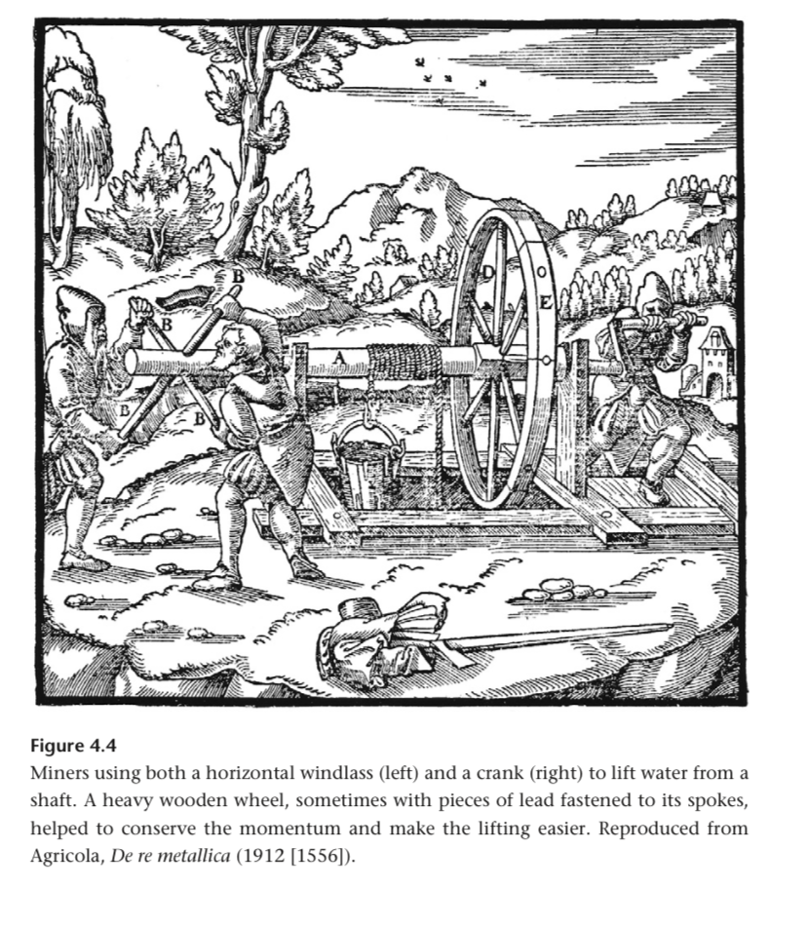

Cranks emerged in China is 200, Europe in 900.

The limitation of crank speed being the same as took speed was solved by a large wheel, then belts for gear ratios. Momentum helped with non constant exertions too.

George Stevensons workers used a great wheel to make pets for the first steam locomotive had to rest every 5 minutes.

Tread wheels used back and leg muscles. Better than hand turned rotaries.

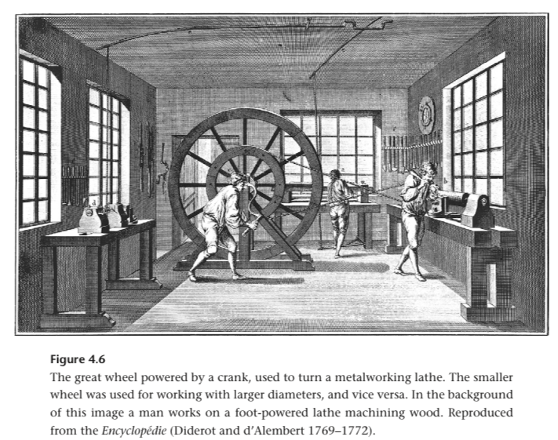

Largest tread wheels were called great wheels.

English prisons, treadwheels became common in the early 19th century. The largest treadmills were in prisons. Banned in 1898.

Coulomb (Charles Augustin) noted that people require less space to work than animals and are easier to transport.

You can mill clay for tiles?!

Horses are more comfortable walking in 8-10 meter circles than 6 meter circles.

What’s the etymology of draft horse.

There were 28 passenger 4 horse horse cars. Care on rails drawn by horses. 1880s, electric street cars introduced. Much overcrowding. Hourly departures, reaching 8-10 km away destinations in one hour.

Urban horses were fed by 8-10 kg of oats and 8-10kg of hay every day.

Al-Masudi’s 947 report of simple vertical shaft wind mills in eastern Iran. Wind irrigated gardens.

Domesday book or 1086 reports 5624 water mills in southern England. One per 350 people.

The best water wheels got up to 50% efficiency and 3.5kW. Horizontal ones were the least efficient.

In the Roman Empire, <1% of mechanical energy total was water wheels.

There’s a trade off between wooden planks trying to harness the kinetic energy of water and bucket that harness the gravitational potential energy of water. You can get less spillage with the ladder probably.

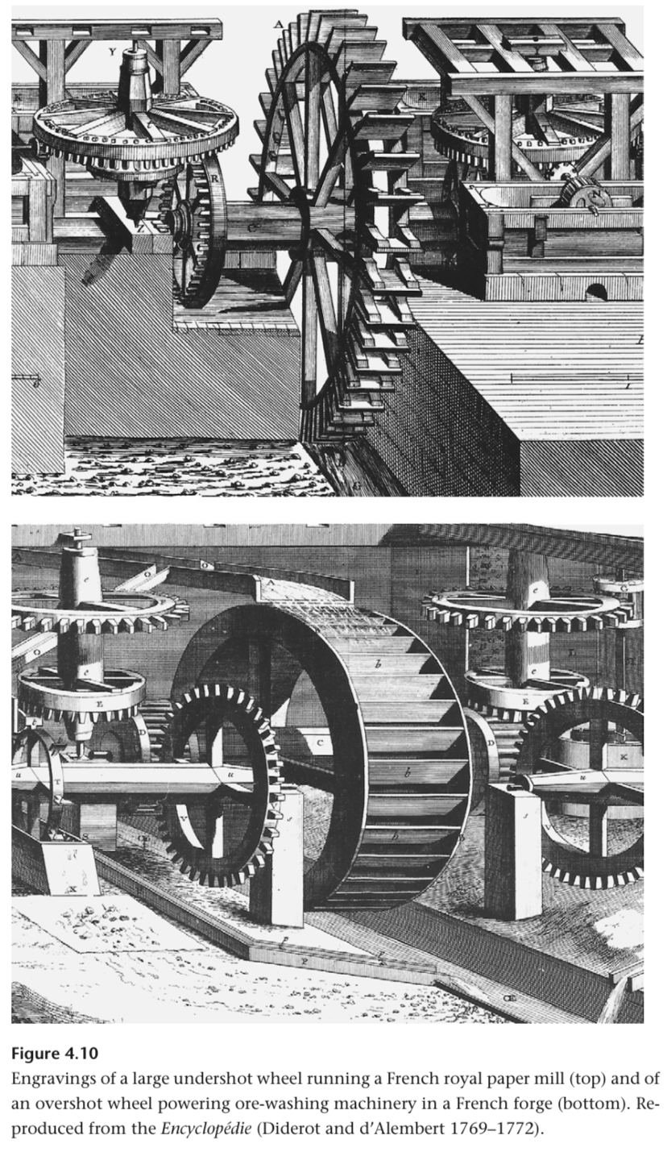

Undershot vs overshot water wheel, I assume it’s the length to height ratio of the paddles.

Useful power depended on the material. For a 12kW theoretical power, heavy wood eheel would get 4kW useful mechanical work, while carefully crafted metal wheel would get 9.

Achievable Efficiencies: 71% overshot wheels, 30% undershot wheels.

Best German wheels in the 30s were up to 76%.

Tidal mills were built generally along the Atlantic coast of Europe, up to the Netherlands. Intermittent flows.

In medieval England, grain milling was 90% of all mills. Common. Most of the rest used for cloth fulling (fulfening up and thickening woollens) and 1% for other industrial uses.

The only way to get increases power was many small installations. A Roman mill line in Barbegal had 16 wheels at 2kW each. A wonder of production and power.

Poor finishing and gearing (high friction) resulted in low efficiency.

Late 18th century, water wheels greatly increased productivity.

US Patent for cutting and heading 200k nails per day. 1795. These machines brought down nail prices by 90% over 50 years.

1850, US waterwheels generated 2.4 PJ. 2.5x coal powered steam engines. Late 1860s, they were surpassed in useful work.

1840, British had a 1.5MW waterworks bear Glasgow. 30 wheels in two rows on a steep slope. Largest were 20m diameter.

Even bigger wheel powered water pumping from a mine. Remarkable stuff. 430kW.

Reaction Turbine with radial outward flow built in 1832. A 1.3m head and 2:4m rotor diameter, it had a capacity of 38kW.

Then various other designs, inward flow, jet turbine (not that jet), and others.

A river basin in Massachusetts and souther New Hampshire had 60MW of installed capacity.

By the end of the 1800s, most water turbines stopped outputting mechanical work and were used to run generators.

European windmills in the 12th century. They spread from Persia to the Byzantine territory, where they were turned into vertical machines encountered by the crusaders.

The structure and gears of windmills pivoted to be able to manually be aligned to the wind.

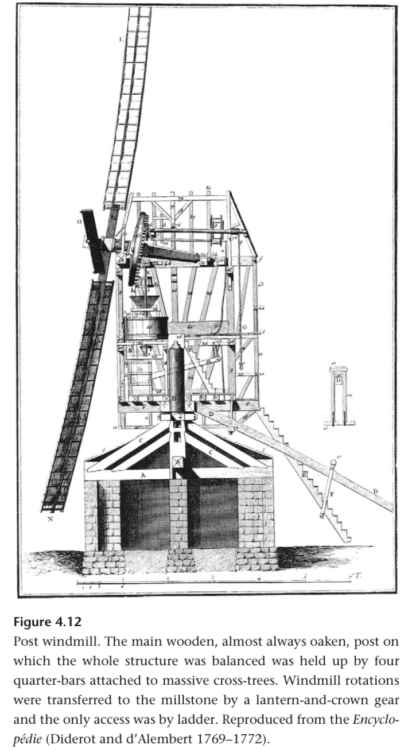

745, English mechanism to point the mill automatically.

End of 1800s, airfoils installed by the English. Took that long!

Above 10-12 m/s, sails had to be trimmed or furled. 5-7 hours per day of useful work. Sustained brisk winds best.

20-30% efficiency.

First Dutch drainage mills in the 15rh century, common a century later.

During the 19th century US great plains expansion, small streams and little rainfall precluded water mills, so you needed windmills.

Smaller American windmills extracted water from underground. Didnt need to be as big as the Dutch.

Usually one of these Halladay windmills per farm or railway. They pumped water for steam locomotives too!

1849, US windmill capacity of 320MW. 500MW in 1890. Peak of 625MW in 1919.

Large 18th century Dutch mills with a 30m span could output 7.5kW.

Dutch water pumping mills could have wind shaft power of 30kW, but very high transmission losses to <12kW.

Wind power scales with the cube of velocity.

American mills ranged from 30W for 2.5M span, up to 1 kW for 7.4m span.

Medieval windmills could get as powerful as water mills. Early 19th century, you got 5x more powerful water mills. Later, water turbines.

High tens of thousands of windmills in the 19th century, then decline.

Early 1920s, US windmill count started to decline after the westward expansion. This was decades later than in Europe.

1889, 77 manufacturers in the US presumably. Halladay, Adams, Buchanan.

Early biomass fuels were used in firing bricks and ceramics, making glass, smelting and shaping metals.

Ancient China, coal was used in the north in iron making. Natural gas burned elsewhere to evaporate brines and produce salt.

1870s France, coal was half of all fuel energy. 1884 US, coal, oil, and a little natural gas surpassed the energy content of fuel wood.

Early biomass fuel needs were cooking 3 meals a day and heating at least one room in cold climates.

Specific density of some oaks is almost twice as high as some poplars.

Wood is 40% cellulose, 30% hemicelulose, and the rest is lignin. Carbon and oxygen both 40-50% each in mass.

Lignin is 1.5-2x higher energy density than cellulose. Just remember 20MJ/kg as a standard number, likely lower.

Vaporising moisture inside of wood is not efficient. Recently cut trees can be up to 30% water. Months of drying to get to 15% moisture.

Charcoal is virtually smokeless and 50% higher mass energy density.

Traditional production of charcoal wasn’t efficient.

Partial combustion of wood in earth or pit kilns generates the heat for carbonisation. No need for additional fuel. 15-25% yield.

Carbonisation is a subset of pyrolysis which is a subset of thermal decomposition. Pyrolysis is specifically thermal decomposition in the absence of oxygen.

Charcoal production was inefficient but burned on its own up to 900C. With supplementary air supply, up to 2000C. Achieved with bellows.

Harvesting of wood for fuel and ship building led to wide deforestation.

Early 18th century, 85% of Massachusetts was forests. 1870, only 30%.

In places still dependent on biomass fuels post 1950 they use 500kg per capita per year in tropical regions. 5x more in cold climates that use bricks.

In Germany, 2 tons of wood burned to obtain potassium made 1 kg of glass.

Estimate of 650kg biomass fuels per year per capita in the Roman Empire.

Roman had an average annual consumption of 2kg of metals. 60 kg of wood required for 1 kg of metal.

Roman combustion efficiencies were <15%. Useful energy output was 1.5GJ per year. One tank of gasoline.

1850s, household combustion was the majority of wood usage.

Crop residues like wheat stalks and branches.

Low density of crop residues means you have to stoke fires and keep adding mass constantly.

Sheep dung produced acrid smoke so it’s the one dung that is avoided. Cattle and water buffalo. Sometimes for cooking even in modern day.

Before grains can be cooked they have to be processed. Milling is a historically universal first processing step.

Extraction of oils by pressing seeds fruits and nuts came after milling.

East Asian stir frying and steaming required little fuel relative to baking bread and roasting like in the Middle East and Africa.

Whole grain is difficult to digest and can’t be used for baking.

Milling produces flours. You can get breads and noddles.

Two romans slaves rotary grinding flour could produce <7kg per hour.

Mill stones driven by a small 1.5kW water wheel could grind 80-100kg of flour per hour.

Bread was 50-70% of all food energy.

Vertical waterwheels required wooden gear transmission.

Grain hopper into a chamber with massive stones that had to be precisely balanced. Can’t be too close (damage) or far (rough grains). Millimetres or less.

Stones serviced every 2-3 weeks.

Intermediary particles can go through again, then sifted to sort into various qualities of grain.

1785, first automatic grain mill designed by American Oliver Evans. Proposed endless belts (like Archimedean screws) to transport flour. Self published a book on milling that became successful.

Flat breads were stuck to the sides of clay ovens and leven breads placed on flat surfaces.

Energy shortages promoted low energy cooking methods, various south East Asian techniques. Wok.

Fireplaces were uncommon until the 15th century.

Benjamin Franklin designed a stove in 1740 that was essentially a stove inside a fireplace.

Iron fireplaces became common in the 18th century.

1798, Benjamin Thompson designed a brick range with top openings to place pots and an oven. Large kitchens adopted it.

Fireplaces had heating efficiencies of 5-10%.

Fireplaces could cause heat loss in a room by taking warm air outside. Impeding this draft caused CO to build up. Radiative heating from fireplaces wasn’t enough.

Hypocaust, Greek invention, led fireplace exhaust through the floor of a room above. 300 BC.

Romans used it for bathhouses and then in colder provinces.

Chinese made a similar design with a bed and stove. Heat exchanger.

Japanese couldn’t put these in their wooden houses. They relied on charcoal braziers.

First fat burning oil lamps in Europe 40k years ago. Candles in the Middle East after 800 BC.

The bright spot on a candle flame was irradiance (light per area), 20% of a clear sky.

American whaling fleet had 700 vessels in 1846, world record. The first half of that decade had 160,000 barrels of sperm oil brough to Britain each year.

A few seconds into Usain Bolt’s world record 100m he was at 2.6kW. Running requires ~800W for a man at a reasonable pace.

Battle of Marathon. The Spartans refused to help. That man burned 800W.

Experienced riders could do 50-60 km per day, changing horses gets that to 100 km per day.

Postal services preferred 13-16 km/h and around 25 km per animal to minimize damage, they were optimizing.

The pony express served California before the telegraph and railways.

Optimal horse riding form is putting your center of mass low and forward.

Adoption of stirrups in early medieval Europe made fighting and jousting possible.

On rough terrain or slopes, humans are better than animals. More flexible. Porters. Nepali Sherpas can carry up to 30-35kg to base camp, 20kg above that.

Chinese barrows had the load centered over the wheel, a man could move 150kg. European barrows took no more than 60-100kg.

Lubrication cut friction by half for the ancient Egyptians. This is the famous image of 160 men you know 50t load.

Smooth rides versus gravel versus sand or mud had huge differences in energy. On roads, 30kg to move a 1t load. 5x more on gravel. 5x more in sand or mud.

Axel lubricants of tallow and plant oils used since 2000 BC.

By around 250, Rome had 85,000 km of roads. Total energy cost totalled 1 billion labour days.

Pack animals were better than oxen. The saddle around 500BC accelerated this.

The Incas in the 13-15th century consolidated the empire by building 40,000 km of roads. All weather with distance markers.

One winding through the Andes paved with stones 6 meters wide on river terraces.

Deep exchavation and refilling with other material.

Messengers on fast horses maxima on Roman roads was 380 km/day. 10-15 for men with wheel barrows.

It cost more to move grain 120km by road than to ship from Egypt to Rome. From Austria, rimes harbour, it was loaded onto barges that moved against the Tiber to avoid land transport.

My god water was fundamental.

Mid 1800s maximum allowed French load was increased to 1.4t, 4x the Roman limit.

1890s, peak horse, electrification and ICE solved it.

Bicycles earlier were dangerous contraptions. 1880s, rapid improvement.

Until the early 1980s, there were no private cars in China. Bicycles!

China produces 80M bicycles per year 60% exported.

Oared vessels required hard labour in confined quarters below deck. Exhausting labour and a complex design of organizational mastery of dozens of men or more.

Larger oared ships followed after Alexander’s death in 323 BC. Greek oared ships are amongst the most studied.

During Ptolemaios Philopator’s reign (222–204 BCE). 126m long ship, 4000 oarsmen. 3000 troops. 5MW theoretical total output. High weight, heavy catapults, virtually immovable, miscalculation.

Venetian galleys with 56 oars crewed by 5 men. Large Māori dug out canoes were oared by almost as many.

Sung dynasty in China, paddled ships with 200 men on treading pedals. ~15th century.

Early canals used double spill ways, oxen hauled boats up to a higher level. Inefficient. The canal pound block in 983 solved this, no water wasted.

Canals were a large share of European cargo hauling before railways and a few decades after.

Sails are fabric air foils designed to maximise lift and minimise drag.

Roman sailing ships could go from Messina to Alexandria in 6-8 days. The return journey would be 40-70 days. Northwesterly winds were paramount.

Between November and April there was no shipping between Spain and Italy. Back to transfer windows.

Early Egyptian ships could only manage a 150 degree angle. Between wind and direction? This is the range?

Post Renaissance ships could move at an angle of 80 degrees into the wind. Again, it’s all managing drag and lift.

Modern yachts get to 30 degrees, whatever that means, which is near the aerodynamic maximum.

With poor allowable angles, you need to constantly change course. Zig zag course.

A single 90m^2 one ply sail took a single craftsman 5 years. Sheep herds too.

Large gunships became the dominant class of ships before steamships. 74 guns, 750 men for one French design. The British Royal Navy commissioned 150 gun ships.

1519, Magellan died in the Philippines.

Juan Sebastian Elcano completed the circumnavigation of the globe.

Roman ships were around 100 tons of cargo. The Santa Maria was 165. Roman ships traveled at 1-2.5 m/s.

There’s a grand story of Portuguese exploration before Columbus. The equator, the cape, india.

During the Dutch golden age, sail ship energy was equal to windmill energy which was 5% of total. Mostly peat.

4 fundamental structural members: walls, columns, beams and arches.

Sun dried bricks could be made anywhere with clay. Not many large trees. Stones expensive to transport.

Elaborate surface finishing of wood and stone greatly increased energy cost.

Sun dried bricks were the best building material for millennia.

Sumerian epic Gilgamesh describes the Sumerian capital as one part orchards, one part city, one part clay pits.

Mud bricks are poor heat conductors.

Burned bricks used in ancient Mesopotamia, then Han China and Rome.

For centuries they were burned in piles or open pits. Wasted energy.

Firing in mounds or stacks got a uniform temp of 800C.

Enclosed horizontal kilns get you better combustion efficiency and consistency. Wood and charcoal required.

All quarrying by hand, teams of animals and men transported stones. Craftsmen with tools and pulleys. Cranes powered by men. Amazing organization of labour.

Parthenon completed in 15 years. Pantheon in 8.

Pyramids and tombs are distinguished by their massiveness. Cathedrals combined monumentality with complexity and beauty.

Filippo Brunelleschi worked on cathedrals. Ingenious machines to build without ground based scaffolding a massive structure. Machines dismantled by plans kept. Variety of cranes and a laid positioner.

Kufu’s pyramid is 6.5 mega tonnes.

Beyond quarrying and moving stones, all is conjecture. We don’t know how the stones were actually assembled into a pyramid.

No evidence of ramp building rubble anywhere on the Giza plateau.

Herodotus wrote the earliest description of pyramid building. 2 millennia after completion.

They actually might’ve finished it top down, machines to lift the stones up a level at a time, then work your way down.

Smil’s estimate is 10k workers.

Mesopotamian stepped temple towers = Ziggurats

Flskenstein calculated that construction of the Anu Ziggurat took 1500 men 10 hours per day for 5 years. A terajoule.

Would be a fun exercise to calculate energy efficiency of pyramid construction.

Concrete is a mixture of cement, aggregates (sand, pebbles, and water).

Cement produced by high temperature processing of carefully formulated and ground mixture of lime, clay, and metallic oxides in an inclined rotating kiln.

Architraves, like those at the pantheon, could be rolled in a wooden frame.

The concrete in the pantheon didn't use cement as a bonding agent, but like mortar. Mixture prepared on building site.

Soaked lime and volcanic sand from a few kilometres west of Mount Vesuvius. This made the bonding agent presumably, good enough material that it could harden underwater.

The dome of the pantheon has vertically decreasing specific mass. Specific mass is important here, the material makeup changed. 4500t dome.

Cathedral construction interrupted, takes longer.

Every large Roman town had to have a well planned urban water supply. Only surpassed by industrial Europe.

Early cities like Jerusalem also had a aquaducts.

Massive Roman sewer system too.

High energy costs of Roman aquaducts and associated infrastructure mainly came from lead. It could withstand 18 atm.

Lead had to be transported far from smelting centres to construction.

1500 tons of lead for 9 siphons for Leon’s water supply.

The use of colour metals (non ferrous) marks the start of many old high cultures. Copper, tin, iron, lead, mercury, silver, gold.

Mercury liquid at ambient and gold is soft.

Even silver was too rare for mass production.

Copper and bronze dominated the first two millennia of human civilization, thereafter iron and steel.

Charcoal fueled smelting of non ferrous and iron ores. Mining and crushing done by human labour.

Water pumping from mines was a non trivial cost.

Availability of wood and water resources were key determinants of metallurgical progress.

First copper use wasn’t smelted. 6th millennium BC. Pure metal shaped and annealed (alternating heat and hammering).

Smelting and casting of copper became common in 4000BC in regions rich and accessible oxide and carbonate ores.

Tools, rings, etc. left behind by tons of old civilizations. Mesopotamians, etc.

Sinai peninsula, North Africa, cypress, Syria, Iran, Caucasuses, all early sites of lots of mining. Later, Italy, etc.

Copper melts at 1083 C, core reducation done with wood in clay pits sometimes with air holes.

Bellows first seen in Egypt in 1600 BC.

Cast in clay or other material castings.

Producing metal from sulphide ores was more intensive, but it’s more adundant. Raw ore first crushed and roasting in heaps or furnaces to remove sulphur and other element impurities. Impurities would change its properties.

Faster roasting (little fuel required) you get 60-70% copper. After more smelting runs you get into the 90s.

Oxidation, slagging, and volatilization could get even purer copper.

Rio Tinto was the highest concentration of smelting in the ancient world, Spain near Seville.

Roman smelting wasn’t surpassed in extent for 1500 years.

Main product of Rio Tinto in the Roman Era was copper, before this it was silver.

Centuries of copper smelting on Cypress left behind 4 megatonnes of slag. Tons of deforestation.

Local wood shortages would limit the extent of smelting.

From the beginning of copper smelting it was incorporated into bronze, first practical alloy. The edge between the stone and Bronze Age.

Egypt before 2000BC went through a pure copper era. Others in subsaharan Africa went directly from the Stone Age to the Iron Age. It’s a rough definition of the ages.

First bronzes were inadvertently created when ore contained tin. Later, cosmelting of the two. After 1500 BC, they were made by smelting 2 metals together.

Tin, 232 C melting point. This means the energy cost of bronze was lower than pure copper, and it was a better material.

5-30% tin, 750-900 C melting point. Many different bronzes.

Brass is 15-50% zinc. Again, you get the lower melting point.

First brass dates to 100BC. Common in Europe in 1500.

Iron weapons became more common after 1900 BC. Extensive use after 1400 BC. Then it was abundant after 1000 BC.

Iron: 1535 C melting point

Unaided charcoal fire gets to 900 C, forced air supply gets it to 2000 C.

Early iron smelting was done in pits atop hill tops. Maximise breeze. Pits of iron ore and charcoal. Later, clay tubes for more air.

Thousands of crude early furnaces found all around the world. They got to 1100-1200 C, this reduced iron oxide but didn’t melt iron.

The result was a bloom. Iron slag. 0.5-3% carbon. It was hammered down into rod iron at <0.1% carbon.

Han dynasty 207 BC to 220 CE were the first craftsmen to produce liquid iron.

5 meter large furnaces, reinforced clay, could take 1 ton of iron ore, produced cast iron.

High phosphorus content lowered the melting point and double acting bellows we’re both critical ingredients for this success.

Statues made from molds and metal.

European blast furnaces produced in the lower Rhine region.

Pig iron: 1.5-5% carbon. Can’t be directly forged or rolled.

15-16th centuries, larger bellows, then larger water wheel operated bellows.

During the summer, not enough water to get full 7kW output of the largest water wheels.

The strength of charcoal limited blast furnaces to 8 meters in height. Idk what this means.

Charcoal to metal ratios:
Late 18th: 8-1
1900: 1.2-1
Swedish charcoal furnaces: 0.77-1

Instead of charcoal they started using coke, whatever that is.

Early 18th century British blast furnaces worked October to may, 300t of pig iron output.

12000t of wood required for a single furnace. After 1700, all accessible natural forests were gone.

Replanting could yield 5-10 tons of wood on average per hectare.

1840, all US iron smelted with charcoal.

By 1880, 90% smelted with coke.

1910, US iron output of 25MT. 125MT wood per year required. 180,000 square km of forests would be required, a third of France. Hence, even America couldn’t energize smelting solely with charcoal.

“Deforestation was the inevitable environmental price paid for making nails, axes, and horseshoes, as well as mail shirts, lances, guns, and cannonballs.”

17th century English energy crisis with iron smelting ramping up and ship building.

Like cast iron, steel is an alloy that contains 0.15-1.5% carbon with nickel, manganese, and chromium.

With 2 meter cone shaped clay furnaces in the Middle East and Africa, 8 men on bellows could get to temperatures of 1800 C with charcoal.

Most steel was initially created by carburizing rod iron or decarbonising cast iron.

Carburizing meant long periods of heating in charcoal. Without more forging, you’d get a hard steel layer around a softer iron core.

Decarburization meant oxidising iron. Han dynasty China.

Iron tools and even utensils made everything easier. This is actually fundamental. Warfare, etc.

Until the invention of gun powder, weapons were not the prime movers of war. Human and animal labour.

Kinetic energy drove most wars until chemical energy took over.

Old Greek and Chinese cross bows shot enemies up to 200m away.

Heavy medieval swords were no more than 2 kg.

Expert Japanese swordsmen could get a katana to 10m/s. 75J for a 1.5kg katana.

Highly concentrated force, so 75J goes a long way.

Catapults are large bows powered by sudden release of the elastic deformation of twisted ropes.

The various projectile weapons were different class levers.

Mangonels were third class levers.

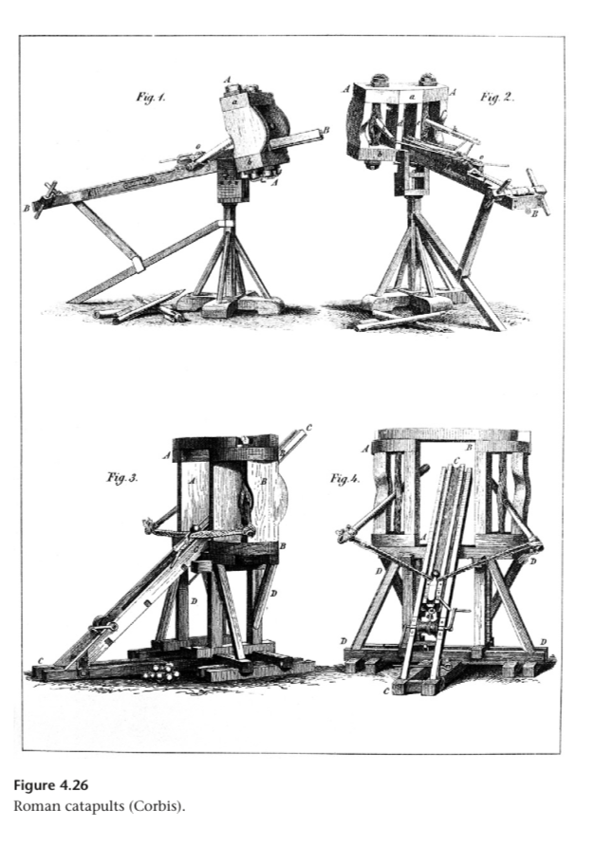

Terbuchets were invented in China, first class lever, more powerful. Counter weights over one ton.

Trebuchets were also used to prevent any sieges by destroying siege construction.

Horses were very important military technology. Genghis Khan, Crusades that made it to Jordan and Israel.

“Epoch defining napoleonic wars.”

Great mass requirements for large military campaigns relying on draft power. Oxen and elephants (sometimes) pulling.

44k oxen to pull supply wagons readied in Prussia before Napoleon's invasion of russia. 1812.

Late 1917, British armies on western front had 368k horses. ⅔ of them logistics.

Germany mobilized 625k horses for the invasion of Russia 1941. Soviets similar when marching to Berlin.

Hay and Oats were strategically important material until the end of WW2.

One of Napoleons generals, Philip Paul, comte de
Ségur (1780–1873), described the Prussian treaty with Napoleon (presumably after defeat) as opening the road to Russia.

Near a hundred thousand animals and million of bushels of oats. 2 million bottles of beer.

Philip Paul is one of the most famous chronicler of Napoleons distasterous invasion.

Chinese alchemists and metallurgists worked with the three ingredients of gunpowder for a long time. Potassium Nitrate (KNO3, saltpetre), Sulfer, Charcoal.

Mid 9th century, first gunpowder formula. Clear directions for creation of gunpowder in 1040.

Early mixtures 50% saltpetre and not capable of detonation. Later, 75% saltpetre, 15% charcoal, 10% sulfur.

Gunpowder expands 3000x when turned into gas. Supplies its own oxygen.

Artillery development started with Chinese fire lances in the 10th century. Bamboo and metal tubes ejecting bits of materials.

This evolved into simple bronze cannons hurling loosely fitting stones.

Before the end of the 13th century, the first guns were cast in China. Europe in a couple decades.

Rapid innovation in guns.

By 1400, longest guns were 3.6m, 35cm caliber.

Then, from stone balls to iron projectiles.

Accurate artillery made castles indefensible. Fewer long hopeless sieges.

Medieval compact fortresses with thick stone walls were superseded by low spreading star shaped polygons.

Sebastien Vauban, French military engineer, built Longwy. The fortress required rocks and earth moved equivalent to a quarter of the volume of Khufu's pyramid.

18th century resulted in more mobile warfare. Fortresses fell out of style. Guns got smaller and made faster maneuvers easier.

Compasses and good rudders were Chinese innovations. Gunships improved and spread European technological supremacy to the world.

They were superseded by steamships beginning in the 1820s.

The English had longer range guns, an advantage against the Spanish armada in 1588.

A century later, up to 100 guns a ship.

1692, British and Dutch ships at the battle of Lahogue had a cumulative 6756 guns.

These concentrations of destructive energy were not surpassed until the mid 19th century with nitrocellulose based powders.

5. Fossil Fuels, Primary Electricity, and Renewables

Atmospheric pressure gradients arise from differential heating of the Earth's surface.

Large saws allowed for the use of solar radiation to be postponed several centuries. (Big trees).

The youngest peat is a few thousand years old. 100Ms for hard coal.

During formation of coal, 15% of plant carbon was converted into peat, 90% of that into coal, in open cast mines up to 95% of that coal can be extracted from thick seams.

Crude oil and natural gas arose from organisms buried in marine and lacustrine sediments.

These fossil hydrocarbons are recovered at rates of 1-0.01%.

New prime movers required to not just look like richer 18th century civs. Steam engine, etc.

Also required was new processes to transform raw fuels. Eg. Production of metallurgical coke from coal, refining crude oils, coals and hydrocarbons as feedstocks in new chemical synthesis.

Hydroelectricity is a form of primary electricity, rather than electricity derived from fuel combustion.

Plant mass is 45-55% carbon. Bituminous coals are >85% carbon.

Black coals nearly always contain ash and sulfur. Fly ash and SO2 generated from combustion, two common sources of air pollution until around WW2.

Natural gases are the lightest hydrocarbons.

Note the use of common denominator here:
“International energy statistics use one of three common denominators: standard coal equivalent (fuel containing 29.3 MJ/kg), oil equivalent (worth 42 MJ/kg), or values in standard energy units (joules) or in two traditional units, calories (cal) and British thermal units (Btu).”

Transition from phytomass fuels and animate energies to fossil fuels and inanimate prime movers.

Han dynasty used some coal in the early centuries AD. Around 100-300.

Until the 1600s, coal was used by the poor instead of wood.

During 17th and 18th centuries, the Dutch golden age was fueled mostly by peat.

Russia was a pioneer of large scale oil production. Look more into this!!

Maybe you can model transport as increasing quality hydrocarbons.

Gas turbines are either stationary or power jets/ships.

Han dynasty used coal for Iron production!!

First European extraction in Belgium around 1100. Then shipments to Britain and France.

After 1500, serious British wood shortages. Increased cost of fuel wood, charcoal, lumber. 17th century worsened these shortages.

Shortages slightly eliviated by improtsnt of bar iron and timber.

1540-1640, almost all domestic British coal fields were opened up. Towards elevating the shortage.

1650, English coal extraction passed 2MT/year. Early 1700s, 3MT/year. Late 1700, 10MT/year.

Depletion of coal outcropping seams led to deeper pits.

Early deeper than 50m in late 1700s.

Steadily deeper pits thereafter, to deepest of ~300m in 1830.

Each mine produced 20-40 tons. Compared to single digits a century earlier.

Deeper mines required more water pumping, ventilation, hoisting, etc.

All powered by water mills, wind mills, horses.

Boys starting around 6-8 could do lighter tasks. Mostly adult men working in various roles.

Coal baskets on back fastened by straps to forehead used while climbing ladders. Some women did this work.

1812, Robert Bald, Scottish civil engineer and surveyor, published enquiry into the lives of these women. Painfu kdescription ans accurate appraisal of physical exertion.

Operating near maximum of human capacity from 7 to late age at sustained 330W.

Wood to coal energized by human muscles. Coal combustion powered

“the transition from wood to coal had to be energized by human muscles, coal combustion powered the development of oil, and, as I stress in the last chapter, today’s solar photovoltaic cells and wind turbines are embodiments of fossil energies required to smelt the requisite metals, synthesize the needed plastics, and process other materials requiring high energy inputs.”

Transfer of impurities of coal made its due impossible in glass making, malt drying, and iron smelting (improtsnt!!).

Glass problem solved by reverberating - heat reflecting - furnaces.

Availability of coke solved the other needs. What is coke?!?!?! Improtsnt question!!

Coal gas produced by carbonization of bituminous coal.

A company to provide centralized gas supply in London was chartered in 1812.

Removal of sulfur from the gas, new technique for smaller diameter pipes, and more efficient burners helped rapid diffusion of gas lighting.

By 1650 in England and Wales, coals share was up to 65%. In 1950, 91% of Britain’s energy was from coal.

Coal dominated British energy use for 250 years, longer than any other country.

Early napoleonic France got 90% of its energy from wood. 75% in 1850. Coal dominated France until 1950 when its primary energy source became imported oil.

Russia used tons of wood due to the vast boreal forests. Estimate of 75% of energy from wood in 1913.

China transition from phytomass to coal delayed by endless crises.

1965, biomass fuels began to supply less than half of China's primary energy.

Transition from charcoal to coke!

Metallurgical coke replaced charcoal for pig or cast iron smelting. Meant not dependent on wood or proximity to forests and allowed bigger furnaces.

Pyrolysis of coal produces a nearly pure carbon matrix with low density and high energy density. Coke.

Coke is stronger in compression than charcoal, so it also allows taller blast furnaces with more ore.

Early 1640s, coke was used in Britain for drying malt.

Coke is a “metallurgical fuel” presumably because it’s used for metallurgical processes.

Early 18th century British bar iron prices were depressed due to Swedish imports.

Mid 1750s the market improved (what does that mean? More expensive?) and English iron masters began building new coke fueled furnaces.

1770, coke created 46% of Britain’s iron.

1820, 52% of belgium's forest area was used to produce metallurgical charcoal.

Grok:
The metallurgical prefix refers to high carbon content, low impurities, high temperature combustion, and structural strength (for coke).
Coke is porous.

In 1840 all US pig iron was smelted with charcoal. Wood was less of a concern.

Expansion of the US iron industry brought a switch to anthracite then to coke.

Coke was produced wastefully in enclosed beehive ovens.

Then, byproduct coking ovens. These recover CO-rich gases for fuel, chemicals for raw materials (tar, benzol, etc.), and ammonium sulphate for fertilizer. By-product coking ovens emerged in the late 1800s in UK and later US.

Grok:
Beehive ovens burned off volatile gases. Byproduct coking ovens produced coke and saved the byproducts.

Carbonization (destructive distillation) is fundamental! Thermal decomposition! Volatile compounds are released as the coal breaks down under high heat and lack of oxygen, then only high carbon coke is left.

Coal gas also exists! Methane, hydrogen, CO.

From byproduct coke ovens you get coal gas, coal tar (thick black liquid or benzene, naphthalene, etc.), ammonia, light oils (Benzene or hydrocarbons).

Beehive ovens vented everything but coke.

Still used in parts of China, India, Europe. Electric Arc Furnaces preferable. They release sulfur dioxide and particulates, scrubbers help.
End grok

Early coke furnaces were the same size as charcoal furnaces, <17m3, 8m tall. Later up to 14m tall and 70m3.

Lowthian Bell, metallurgist, redesigned to make a 25m tall blast furnace. 300m3 internal volume.

Charcoal furnaces did <10t/day, larger coke furnaces did 300t/day.

~40x pig iron output from 1750 to 1900. If only we had that S curve.

This was key to industrialization.

Steam engine was the first new prime mover since wind mills 800 years earlier. First prime mover with delayed Solar radiance use.

Early designs gave only reciprocating motion, later with rotary motion (more practical).

The early Industrial Revolution only impacted a few sectors, majority of workers unaffected.

Only later did it start to produce more energy share and after 1840 came the big changes with trains and steamships.

Also, they became used in some factories with belts transmitting kinetic energy.

1712, Newcomen built a 3.75W steam driven pump for mines. Working at atmospheric pressure, it condensed steam on the underside of the piston so had low efficiency.

James Watts innovations: keep the steam vessel as consistently hot as possible, condense steam is separate vessels (condensers, to be kept cold), draw air out with pumps.

A governor maintains constant speed with varying loads.

Drainage was a really huge early reason for steam engines, and for coal mines this benefitted both.

By 1800, when the patent finally expired (25 year extension), Watt and Boldens company completed 500 engines 40% for water pumping.

20kW. 5x median water mills, 3x windmills.

100kW were the largest.

Watt and Bolden didnt innovate much while their patent lasted. One man who worked for them did some development on a steam powered transportation, he was discouraged. William Murdoch.

1777, at 23 William Murdoch walked 500km to take a job with Watt and Murdock.

Bolden convinced Murdock not to patent his early ateam carriage, thought his persistence was a disorder.

It took decades from Watts patent expiring to railroads being commercial. Roads would not suffice, too heavy.

Intense innovation after Watts patent expired. High pressure boilers, uniform design, regulating valve gear, etc.

Went from water pumping to belt drives in factories to locomotives and ships.

1780s, first steam ships. 1802 first commercially successful ship. 20 years!

Most immigrants from 1815-1930 went on steam ships.

1830, Liverpool to Manchester, first public railway after decades of private railways and tests.

Efficiency of ~12%. Up to 200kmph.

1917, trans Siberian railway to the pacific completed.

In 1850-1900 railway expansion was a big part of the reason for increased steel demand.

Also demand from steel industry itself, electrical industry (generators, transformers, boilers), oil extraction and transport, steel hulled vessels, manufacturing, textiles and food.

Rails went from being made of rod iron to cheaper Bessemer steel.

From 1800 to 1890, 2.5-25% efficient, 100kW to 3MW. 100x increase in operating pressure from 14kPa to 1.4MPa.

Why is k lower and M upper?

Coal powered steam engines were limited to water and rail due to weight.

Early steam engines were 600-700 g/W, near people and draft animals. By 1900, 60g/W. Still too heavy for road transport.

Gasoline engines: Beginning of WW1, got to 10g/W and >25% eff.

1905, London Greenwich station, 3.5MW compound steam engine in cathedral-like space. 14.5m tall.

Internal combustion engine made possible by liquid fuels. Higher energy density, cleaner burning, easier transport.

Percussion drilling allowed the Chinese around the Han to use liquid fuels to dry brines. Iron bits raised rhythmically by 2-6 men with levers, jumping. 10m deep, 150m around 1000. 1km by 1800s.

Bamboo pipelines.

1806, Absheron peninsula under czarist Russia with many shallow wells extracting light oils for distilling into kerosene for lighting and export by camels with skin bags and wooden barrels.

First oil distilling factory built by Russians in 1837. 1846, world's first exploratory oil well (21m), Balakhani. Massive field is still producing today.

American oil was from motivation to find replacement for whale blubber oil that was rendered on ships.

1846, 700 whaling vessels at peak.

Southwestern Ontario, first oil well drilled in North America.

First drilled well August 27 1859 near Titusville Pennsylvania. Dawn of the oil age.

It was drilled with a percussion drill powered by a small steam engine.

Canadian output increased with a gusher. Huh, natural occurring oil spilling out of the earth spontaneously?

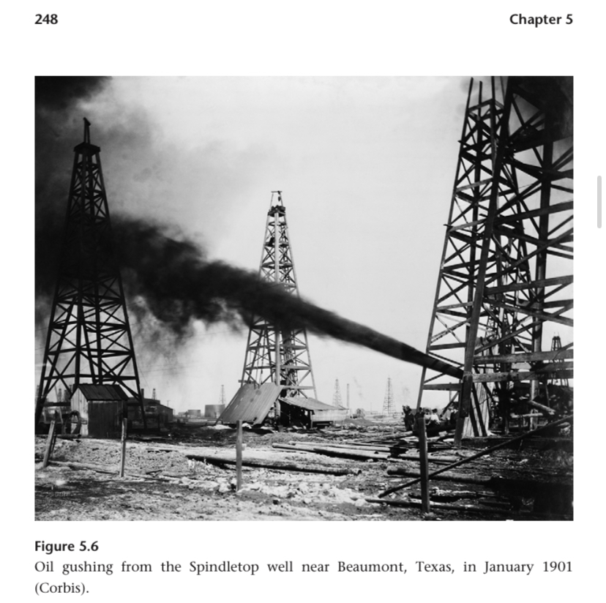
Now thats a gusher!

Russian oil industry received foreign investment. Ludwig and Robert Nobel and Rothschild brothers capstan and Black Sea oil society.

1899, before discovery of oil in Texas, Russia was briefly the largest producer of crude oil. Only crude? Exported for refinement or less efficient or different uses?

Yep, most exported by the foreign investors.

A spread of oil discoveries around the world early 1900s.

Most discoveries were crude oil and natural gas. With compressors and steel pipes natgas couldn’t be moved far, so vented.

25 years after oil began to be used for lighting, electric light bulbs were superior.

Design of the ICE engine didn’t change much in principle from 1886-1905 with first generation all through 1900s.

First commercial ICE engine patented by a Frenchman in 1860. 4% efficient.

1877, another ICE engine patented and sold 50k units. Nicolaus August Otto. 6kW and compression ratio of 2.6. Sold to small workshops that couldn’t afford a steam engine. It was coal powered I think?

Daimler after working for Otto and Maybach designed an engine to burn gasoline.

Gasoline had 1600x higher energy density than the town gas used by Otto. -40 degree flash point makes the engine easy to start.

First prototype in 1883. 1885, air cooled version posted the worlds first motorcycle.

Then a 0.462 litre water cooled engine mounted on a coach.

Karl Friedrich Benz simultaneously designed a 2 stroke gasoline engine. 4 stroke patented in 1886 after Otto's patent ran out.

Daimler created a high revolution engine, Benz an electrical ignition, and Maybach a flow fees carburetor. Sound familiar? Modern car coming together.

A French engineer designed the first modern car with a German engine.

DMG company founded. Daimler Motoren Gesselschaft.

DMG engines kept winning races.

Emil Jellinek, businessman and the Austro-Hungarian consul general in
Monaco, established a dealership for Daimler cars on April 2, 1900, he ordered
36 vehicles, and soon afterward doubled the order.

Asked for exclusive selling rights in the Austriohungarian empire, France, Belgium and US. Trademarked the name Mercedes, given name of his daughter.

For this, Maybach the first modern car. 1.2t, 4 cylinder engine, 5.9L 26kW.

Maybach reduced engine weight to 230kg by using an aluminium block. 9g/W.

This car set a speed record at 64.4 kmph.

DMG focused on affluent markets. Mid 1880s daybue of the car and a couple decades later still for the rich.

Artisanal production methods.

1908, Model T.

Wilbur and Orville Wright around this time as well.

Charles M Manly tried catapulting planes into the air from barges. Second test 9 days before the Wright Brothers. US government grant. Radial engine. Failed test.

5 years prior the Wright Brothers wrote to the Smithsonian to request information about flight.

Charles Taylor was their mechanic, after engine manufacturers refused to build to their specs. 6kW.

December 17 1903. First flights. Quietly monumental day.

Spruce frame, cotton cloth coverings, 283kg. Two counter rotating propellers. Wires control control surfaces. 4th flight that day they crashed, 57 seconds. Against 21mph winds.

Their patent was quickly infringed in many countries.

1909, first English Channel crossing.

Rudolf Diseal invented the diseal engine where injected fuel is spontaneously ignoted hy high temperatures! 2x higher compression ratios compared to the Otto cycle.

The first prototype that underwent certification tests had almost 2x higher efficiency than Otto at 25%.

Best diseal engines are 50% efficient. 2x gasoline.

Diesel is longer chain hydrocarbon than gasoline.

Diseal is 14% heavier than gasoline. Only? Ah, per volume.

Diseal applies for a patent three times while in university. Air compressed so much that the temperature is above ignition temp of fuel and combustion is so gradual that there is no temperature or pressure increase with the piston moving out. Around 1897.

Fiest certification test got to 34atm, with Heinrich Von Buz helping him test. 10x lower than what diseal wanted.

Diseal wanted a small efficient engine to decentralize industry.

He wrote a book that preached a somewhat socialist idea of worker collectives.

Obv the impact diesel engines were the exact opposite of what diesel wanted.

<300 units by 1901. 1903, first diesel powered vessel, oil tanker on the caspian. 1904, French submarine powered by a diesel engine.

The steam turbine became another prime mover after this.

Alessandro Volta created the first electric battery.

“Faraday set out to answer a simple question—if, as Ørsted demonstrated, electricity induces magnetism, can magnetism induce electricity?”

Faraday did his tests around 1830.

Experimental electrical experiments! How fundamental these were! This is why you do projects instead of just textbooks.

In Jules Vernes 20 thousand leagues under the sea, electricity powered everything in the submarine. Science fiction back then.

Transitions from all previous prime movers were mainly drop in replacement for existing processes. Eg. Mill stones moved by water wheels instead of draft animals.

However, the transition to electricity required entirely new processes and transmission infrastructure.

December 1884, first arc lights in public.

Arc light invention that let it be powered by a dynamo (DC generator) and they spread to many cities in US and Europe.

In arc lights, current consumes the positive electrode.

Resupying these electrodes is non trivial. For 1km of road you’d require much more than 1km of carbon electrodes.

In the new and old world, search for indoor lightning filaments went on for 4 decades.

Edison’s insight was that the race for a lightbulbs was not all that was required, but also a system of power generation and distribution ans metering.

Potentially useful blog post quotes:

“Edison succeeded because he realized that the race is not just to have the first reliable light bulb but to put an entire practical commercial system of electric lighting in place—and that included reliable electricity generation, transmission, and metering.”

“As a result, the creation of the electrical industry was driven, more than in any other case of nineteenth-century innovation, by one man’s vision. This required accurate identification of technical challenges, solving them through tenacious interdisciplinary research and development, and rapid introduction of the resulting innovations into commercial use”

“[competitors] but only Edison had both the vision of a complete system and the determination and organizational talent to make the whole
work.”

Joseph Swan created the first durable electric lamp. 1878. Platinum lead wires ans carbon filament.

Platinum leads had low resistance which would require low voltages and high current and large transmission lines.

Pre-edisonian lamps were all in series powered by a dynamo. Not ideal.

Edison realized you’d need high resistance filaments in parallel at constant voltage. Big contradiction of consensus at the time.

Edison in a patent I think laid out a system that required 118V. Still similar to our modern standard!!

Hughes (1983, 18):
“Edison was a holistic conceptualizer and determined solver of the problems associated with the growth of systems. … Edison’s concepts grew out of his need to find organizing principles that were powerful enough to integrate and give purposeful direction to diverse factors and components.”

He had legendary physical endurance too.

He had a Menlo Park laboratory. Precursor of modern corporate R&D labs.

In 3 years since unveiling his light bulb, almost 200 patents on filaments and lamps, magneto or dynamo electro machines, system of lighting, electricity distribution, electric meters and motors. Concurrently, he and coworkers made them all real.

New York, Pearl Street Station, Sep 4 1884 commissioned, first American thermal power plant. A month after opening, 1k lightbulbs, a year after, 10k were wired.

Large number of innovations to make Edison possible, mainly in the 1880s.

Incandescent was succeeded by fluorescent lights in the 30s, then sodium Vapor, sulfur lamps, LEDs.

As earlier, early steam engines had poor mass/power ratios.

Charles Parsons patented a more efficiently T lighter steam turbine and displaced the old engines.

Parsons largest pre WW1 machine was 25MW in Chicago. 75kW in New Castle in 1888. 1MW in a German station in 1900.

This Parsons man must have quite a story, steam turbines all across the new and old world!

Steam turbines can function from 1 GW to kilowatts. They fill many niches.

Transformers allowed for inexpensive centralized electricity generation possible.

Early DC had a range of a quarter of a square mile. Extending beyond that would require subways for the cables and connectors.

Early DC was in channels under curb stones.

Faraday discovered induction.

Resistance declines as the inverse of of the square of voltage. 10x voltage = 100x lower resistance losses. Obvious arithmetic but must understand this.

Losses are around 7% now.

Corona discharge and insulation etc. are the limiting factor for voltage of transmission lines.

Electricity grew a lot before WW1.

George Westinghouse was an early promoter of AC. Edison did personal attacks against him in his crusade against AC.

AC and transformers were a complete, simple, reliable solution to the transmission of power (electrical or otherwise). Stanley made this observation during his 1912 address to the American institute of electrical engineers.

Edison wanted to completely eliminate and prohibit AC.

“My personal desire would be to prohibit entirely the use of alternating currents. They are as unnecessary as they are dangerous … and I can therefore see no justification for the introduction of a system which has no element of permanency and every element of danger to life and property” (Edison 1889, 632)

Edison wanted to boost the value of his shares making DC components. Once divested, conflict ceased.

Reliable cheap AC meter in 1889.

1891 DC systems were supplying half of US lighting.

Charles S Bradley (former Edison employee) patented the rotary converter. This allowed AC to DC. 1891.

Worlds largest AC link for a time was from Niagara Falls to Buffalo.

1900, highest HVAC voltages were 60kV, in 1923, 150kV.

1894, Nikola Tesla patents the first practical polyphase induction motor running on AC.

Late 1830s, first battery powered dc motor designs.

First commercially successful DC motor was patented by Edison ans powered by a bulky battery. 1876. It would be used with a stylus to mechanically duplicate documents.

Edison didnt care about AC, this drove Tesla to found his own company.

Tesla filed 40 patents between 1887-1891.

July 1888, Westinghouse bought all of Teslas AC patents.

1889, Westinghouse had their first AC motor device, a small fan. By 1900, 100k units sold.

Mikhail Osipovich Dolivo-Dobrowolsky built the first three phase motor with AEG. Tesla started with 2 phases.

Three phase power means more even power flow. Greater number of phases is still better, eg. 4 phases. Is this superposition? No, multiple wires.

Photo mass fuels to fossil fuels. Animate to mechanical prime movers. Big changes.

In 1800, steel extremely rare. 1850, limited quantities with a few hundred tons produced annually worldwide. 1900, global output of 28MT.

1917, US peak draft horses.

1900, most electricity used for lighting.

During 1900 all components of the new energy system made improvements except during WW1 and Great Depression.

WW2 accelerated Nuclear energy and gas turbines (jet engines), and rocket propulsion.

All new energy technologies were reaching peaks in 1970, then plateaued.

Leveling off was not due to technical limits but due to prohibitive costs and unacceptable environmental affects. But what really happened in 1971?

“After decades of Maoist misery the world’s most populous country embraced reform policies that quadrupled its per capita use of primary energy between 1980 and 2010.”

2009, China became largest energy user. Different split between industrial and residential.

“Forecasts and scenarios abound, but the history of energy advances has shown that failure to foresee is their most common trait.”

Fossil fuels are not equally distributed, this lead to global trade. Non trivial prerequisite.

A shift to higher quality fuels means relative decarbonization (higher H to C ratio!!)

H:C ratios:
Wood combustion: 0.5
Coal: 1
Gasoline/kerosene: 1.8
Methane: 4

So where is the energy? With the hydrogen? Carbon is just the carrier? We don’t care directly about it too much? What does it do in the combustion.

Carbon intensity of the worlds fossil fuel use declined. 28kg C/GJ in 1900 to 25 in 1950 and 19 in 2010.

High carbon fueled (coal and wood) supplied 94% of energy in 1900, 73% in 1950, 19% in 2010. But again like my first blog post chart, did use decrease on magnitude?

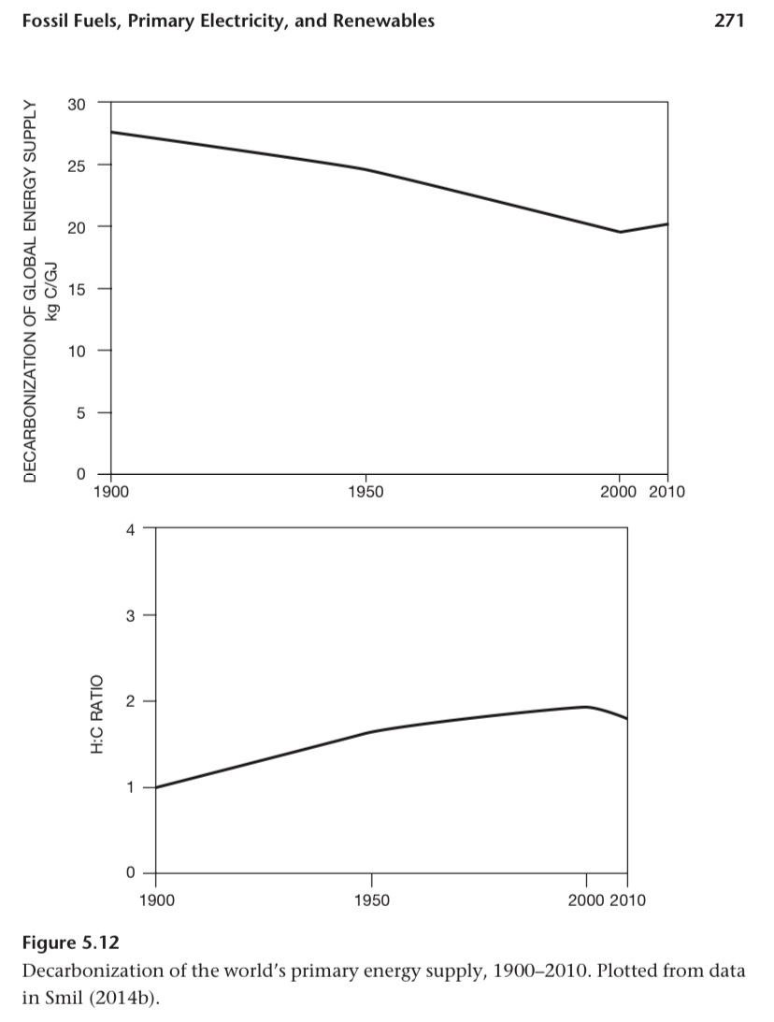

Hydroelectric dams were the original renewable electricity.

Other renewable electricity has low capacity factors.

“The two universal trends in coal production have been the growing mechanization of underground extraction and the rising share of surface mining.“

Coal productivities:
1900: 1t per worker per hour. 2016 average: 5t per worker per hour. Range of 2-3 in Appalachian underground mines to 27 in surface mines of the powder river basin of Montana and Wyoming.

Coal stopped being used for traditional industry, homes, and transport. Made up for by electricity and slightly by metallurgical coke.

After WW2, increasing share of surface extraction of coal made it cheaper.

Some surface deposits have power plants built directly next to them.

Pig iron smelting: 30 megatonnes in 1900 to 1.2GT in 2025. Coking coal is about 1:1 ratio in production at 1.2GT.

1947, British labour government nationalized the coal industry.

A few noisy bits on the chart of British coal production during strikes.

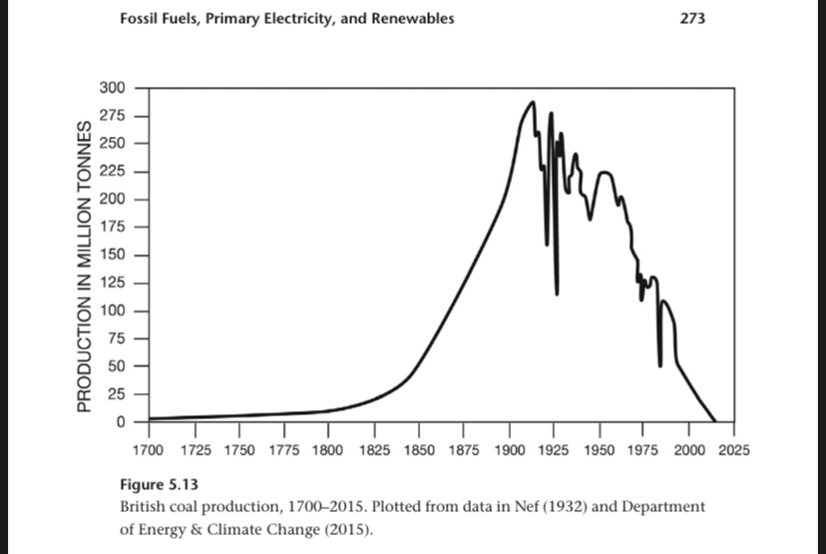

June 2015, final coal mine closed.

Early 1920s, British coal peak employment of 1.2m workers, 7% of total labour force.

90% of all US coal exports are burned in thermal power plants.

US, 2001 1.2GT peak coal production.

US beat USSR in coal extraction in 1983. Then China wins in 1985.

Natural gas and oil picked up as USSR/Russian coal declined.

Chinese coal enrrgy share: 90% in 1955, 67% in 2010.

1949 to 1957, 4x coal output. Then 3x again to the Great Leap Forward in 1960.

32, 130, 400, megatonens. Then 600Mt in 1978.

1900, oil produced 3% of energy from fossil fuels world wide. 1950, 21%. 1972 peak at 46% of all fossil fuel energy.

Wood was the primary energy source before 1900. And on net coal dominated the 20th century (see numbers above).

Modern coal market contracted to two major markets, electricity and coke. Meanwhile liquid hydrocarbons were substituting existing markets and creating new ones.

Jet engines are what allowed commercial aviation to grow spectacularly after 1950. The way of the future, there must be a fascinating history here.

Technical advances in the oil industry:
- Prospecting (electrical conductivity measurements 1912, resistivity well 1927)
- Extraction (rotary drilling 1901, rolling cutter rock bit introduced by Howard Hughes in 1909, more bits, better monitoring techniques)
- Secondary and tertiary recovery methods (water, liquids or gasses to force oil out of the ground) improved oil lifespan and productivity (used to be 30% of oil in place was recovered)

1900, near shore drilling off the coast of California.

1947, first out of sight of land rig drilled off Louisiana.

Recent production advances: non conventional oils like heavy oil, extraction from tar sands (Alberta ans Venezuela), and hydraulic fracturing to produce oil from shales (shale is a type of clastic rock).

Fracking is what allowed America to become the largest producer of oil once again.

During World War 2, the US built oil lines from the gulf to the east coast.

These were surpassed in the 1970s but lines going from Siberia to Europe.

The Ust-Balik-Kurgan-Almetyevsk line Is 1.2 meters in diameter and moves 1.2MT of oil per year.

Until 1936, thermal cracking was the norm. Then, Eugène Houdry began producing high octane gasoline at Sun Oils Pennsylvania refinery through catalytic cracking.

Catalytic cracking allowed more production of lighter oils from intermediary and heavy compounds.

Refining benefitted from desulfurization.

1886, the first oil tanker. Built in Britain for Germany. Rated for 2300t. 1920s, ships up to 20,000 dead weight tons.

The US T2 tanker used in WW2 had a capacity of 16,650t dwt.

1959, first 100,000 dwt ship. Then up to 300k, 150x from the first.

One million dwt ships aren’t practical. Can’t fit in the Suez or Panama.

In 1964, oil energy surpassed coal, since then it's the most commonly used fuel.

In 1900, natural gas was 1% of fossil fuel energy. 1950, 10%. 2000, 25%.

Small but most important market: feedstock and fuel for ammonia synthesis.

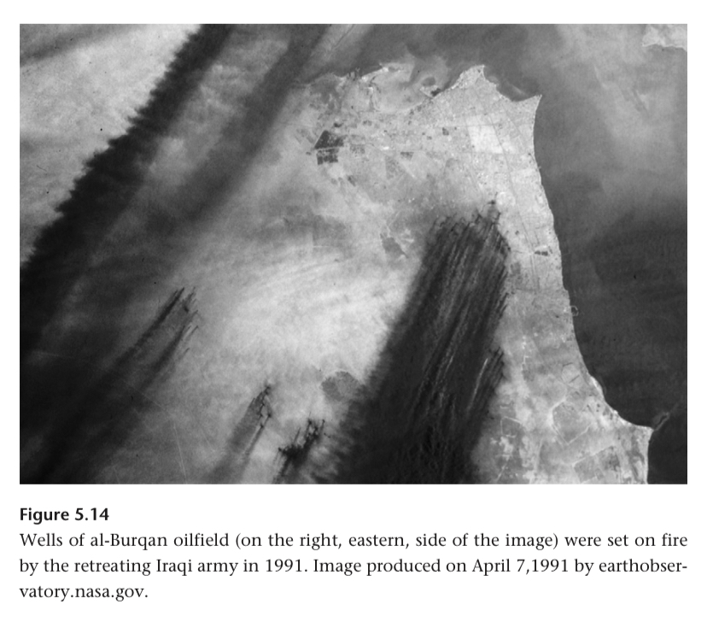

It’s not difficult to remove sulphurous compounds from fuel before use. How not difficult?

During the three decades after 1960, the East Asian nations with no LNG reserves of their own began importing. In 2015, a third of all natural gas exports were by tanker.

Qatar has the world's largest gas field in the Persian gulf.

China is becoming an importer of LNG while the US increases production and becomes less reliant on Canadian imports.

The earliest boilers for electricity were relatively small with lumped coal on moving grates.

In the 1920s, there were multi story boilers burning pulverized fuel injected into the combustion chamber then heating water circulating in steel pipes lining boiler walls.

US gas produced electricity was 12% in 1990 to 33% in 2014.

Japan closed nuclear plants after Fukushima so natural gas was 28% in 2010 to 44% in 2012.

Large boilers supply the steam to the turbines.

The largest is at a French nuclear plant at 1.75GW. 40% efficient because of high temp and pressure.

60% efficiency is possible by using gas turbines and steam turbines. Hot gas leaving the gas turbines produces steam. This is a combined cycle gas turbine.

Large Diesel engines are used in remote areas and for backup capacity.

After WW1, systems grew from urban to national scales. This involved pursuit of economies of scale in station sizes, high voltage links for transmission (particularly from remote hydro stations), and interconnections of smaller systems.

After 1980, air pollution concerns meant plants were moved closer to fuel sources. A shift to mine mount power plants.

This meant more need for HV transmission and transformers.

Since the 1890s, the power of transformers increased 500x and 100x transmission voltages.

Transmit on lines started with wooden poles and solid copper wires. Then steel towers with steel reinforced aluminum cables.

Highest voltage transmission line is in China at 800kV. Carrying 6.4 GW between a hydro station and Shanghai.

Reliability in electricity grids is expressed in 9s.

Industry goal is 6 nines to get 32 seconds without electricity per year. Geez is my house really at 3 nines? 500 minutes per year.

99.98% is current US performance.

The US has many Diesel backup generators. Up to ten million dollars an hour in lost value in cases.

Does BC Hydro have these? Well in my memory outages are all because of local transmission lines falling down or construction of that apartment building.

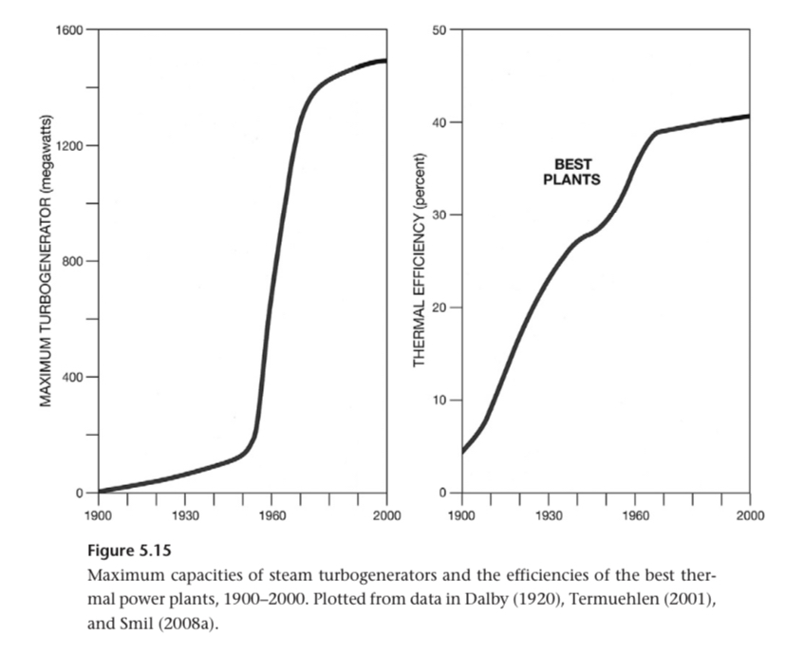

Lise Meitner and Otto Frisch were first to demonstrate fission in December 1938.

First chain reach at the university of Chicago on Dec 2 1942.

July 1945 was the first nuclear test.

August 1945 saw two bombs dropped 3 days apart.

First major post war US nuclear program was developing them for propulsion of nuclear submarines. Nautilus.

Right after the first sailing, Hyman Rickover was put on making the submarine reactor commercial for electricity.

Shipping Port Pennsylvania was the first US nuclear power station. December 1957.

It was a pressurized water reactor, not the best design but it gained a lead over the other reactors early.

277 of 437 reactors in 2015 were pressurized water. In 2015, it was 10.7% of the worlds electricity. 17% at peak before Chinese surge in coal power plants.

Pre 2011 Japan, 30% of power was nuclear.

Austria ans Italy have refused to allow any construction of nuclear power stations. Germany and Sweden are shutting them down. Most stations with plants aren’t building new ones (Canada, UK). Or plants being built below replacement rate of aging plants (US, Japan).

9 reactor projects in Russia. 25 China. 6 India.

Rising dependence on fossil fuels makes biofuels less important.

But, because of growing populations in rural areas of low income countries, with no access to modern energies, the world now consumes more fuel wood and charcoal than ever.

In 2000, biofuels went 2x since 1900 and supplied 12%% of the worlds energy. In 1900 it had 50% market share.

this is the major driver of deforestation in Nepal, central China, India, Central America, etc. best way to solve this is more efficient stoves. 30% compared to 10% traditional stoves.

This substitution was done in China, 75% market share of efficient stoves before 2000.

Lots of biomass is collected by women and children from small trees and groves. Eg. Rubber plantation or backyard trees. Bangladesh, Pakistan, and Ski Lanka study showed this account for 80% of all combustion.

A fifth of crop residues from low income countries in still burned. In Asia, dried dung is still important though Charcoal is preferred.

Traditional biofuels: China, India, Brazil, Indonesian. Absolute use.

Relative use, sub saharan Africa has countries with 80% of their energy from traditional biofuels.

Late 1900s saw large scale ethanol production. Before WW2 ford tried ethanol cars.

Modern large scale ethanol production began in 1975 with Brazils ProÁlcool program fermenting the fuel from sugar cane.

Use corn based ethanol production started in 1980.

Biodiesel market makes liquid fuel from oil rich phytomass like soybeans, etc.

In 2015, liquid biofuels were equivalent to 1.8% of energy extracted from crude oil.

He says biofuels are the most important renewable energy source (traditional and modern, ok or checks out). After that, water.

Hydroelectricity began concurrently with geothermal in 1882.

Appleton Wisconsin, small water wheel powering two dynamos to produce 25kW and power 280 lights.

In Scandinavia and the US, increasingly taller dams were being built.

The first large AC station was built at Niagara in 1895. 37 MW.

During the 1930s a ton of dam projects. US and Soviet Union under Stalinist industrialization.

Grand Coulee dam on the Columbia river had a first stage in 1941 and eventually got to 6.8 GW.

Hoover was 2.1.

After WW2 hydro expanded to 20% of global electricity.

Construction of large hydro projects slowed after 1980, except for China.

Three Gorges Dam is 22.5 GW in 34 units!!!! 2012.

2015, water turbines supplied 16% of global electricity. Up to 60% in Canada! 80% in Brazil, even higher in small African nations.

From 2010 to 2015, wind 2.5x, solar 8x.

In 2015 wind was 3.5% and solar 1% of global electricity.

Modern wind development started with US tax credits in the early 1980s, and ceased quickly when they stopped in 1985.

In the 90s European nations became leaders in wind as they adopted policies to accelerate renewable energy.

Wind installed capacity: 2 GW in 1990, 17.3 in 2000, 432 in 2015.

Edmund Becquerel discovered the PV effect in 1839. Electrodes exposed to light.

In 1954 Bell Labs produced expensive 4.5% efficient silicon solar cells. In 1958, these powered Vanguard 1.

In 1962, Telstar 1 had PV cells rated at 14W.

In 1964, the Nimbus satellites has cells capable of 470 W.

Late 1990s, terrestrial solar started to grow.

50 MW (installed) of PV cells were shipped in 1990. 17 GW in 2010, 50 GW in 2015, with cumulative capacity of 227 GW.

Without tracking and in cloudy climates, Solar PV has capacity factors of 11-15%. In Arizona, 25%.

In 2015, Solar was 30% of wind turbines.

“Again, the industry’s growth has not been a gradual, organic process but a promotion driven by government subsidies: nothing illustrates this better than the fact that in 2015, cloudy Germany produced nearly three times as much PV electricity as sunny Spain (BP 2016).”

Water heating (on homes and industry) predates solar PV. By 2012, installed capacity of heaters was 270 GW mostly in China and Europe.

Concentrated solar power heats water or salt. 5 GW total capacity in 2015.

World's first geothermal plant was in Italy in 1902.

In 2014, 12 GW installed capacity.

Some tidal energy projects, none yet of note in this text.

“Despite many renewable options, some rapid advances, and many contradictory claims, the basic verdict is clear: as with all other energy transitions, moving away from fossil fuels will be a protracted process, and we will have to wait to see how different conversions will evolve to claim key roles in a new energy world.”

Otto cycles: compression ratios doubled during the 20th century and weight decreased resulting in a falling mass to power ratio.

40 g/Watt in 1900 to 1 g/W in 2000.

Ford Model T production ended on 1927 after 19 years an 16M units. It had a ~15kW engine.

Average car power in 1990 was 90kW, 175kW in 2015.

Diesel engines got lighter and more powerful too.

First diesel engine trucks were in Germany in 1924. First heavy passenger cars (with the same engine?) in 1936 in Germany.

Before WW2, most European buses and trucks had diesel engines.

Diesel bus engines have mass power ratios of 3-9 g/W, power up to 350kW, and can drive 600,000 km without major overhaul.

Mass power ratios of diesel engines declined to 2 g/W.

Lower fuel costs made diesel cars common in the EU, 50% of new registrations, 2014. In the US, <3%.

In 2008, Volkswagens illegal software to decrease emissions data in many diesel models was made known.

Diesel locomotives (up to 3.5MW) are used on all non electrified railways.

Before WW1, diesel engines began a conquest for marine shipping. Now rated up to 100MW.

Gas turbines were conceptualised around 1900, first practical designs in late 1930s.

Frank Whittle in England and Hans Pabst Von Ohaon in Germany independently built experiential gas turbines for military planes.

First jet powered planes of course in Germany towards the end of WW2.

Mig-35 reached a max speed of Mach 3.2, fastest fighter.

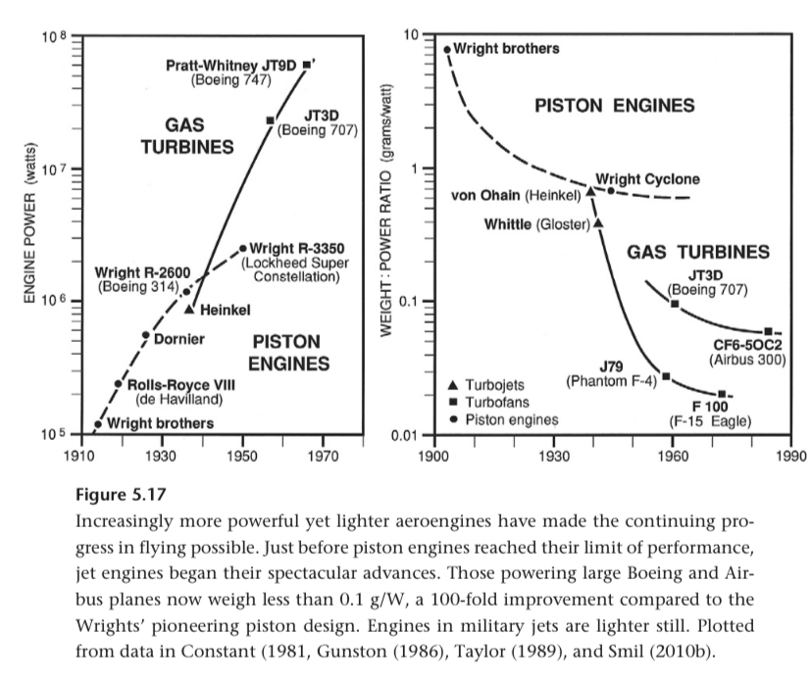

Engines on Boeing/Airbus are now under 0.1 g/W. (See right chart).

Bypass ratio is how much air compressed by an engine bypasses the combustion chamber. Higher means lowering specific fuel consumption and noise.

Most commercial jet engines have 6:1 power weight ratio. Military up to 8.5. This sounded low at first then I remembered I saw comparing to 200:1 rocket engines.

“As is often the case with mature industries, the global market for jet engines has become dominated by only four makers.”

Rolls Royce was first to market commercial jer engines in 1953. Then, GE and Pratt and Whitney. Then CFM making engines for small and medium range aircraft.

1952, British Comet became the first passenger jet. Structural issues caused 3 accidents and cancellation. They redwidnnged and flew in 1958, not commercially successful.

First successful jet plane was the Boeing 707 in 1958.

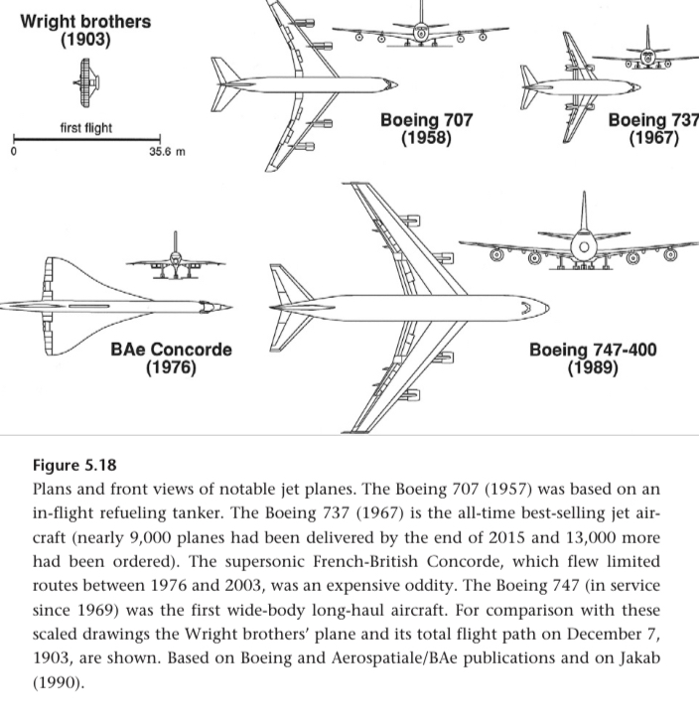

747 peak power was 280 MW.

Rocket engines are the only prime movers that deliver more power per unit weight than gas turbines.

V2 engine was 249 kN with a mass power ratio of 0.15 g/W.

He claims 11 engines kerolox and hydro lox powered the Saturn 5 for 150 seconds.

Apparently total mass power ratio for the entire Saturn 5 was 0.001 g/W, but he gets details wrong and I don’t trust it that much.

6. Fossil-Fueled Civilization

Urbanisation is under appreciated as a source of human advancement.

After 1970, absolute levels of energy use were too high for growth to continue. What’s the proof for this statement?

Extremely exponential increase in fossil fuel use is under appreciated.

Incandescent light was 2% efficient.

Weighted efficiency of energy: 1900, <20%. 1950, <35%. 2015, 50%.

Increased efficiency is under appreciated too!

Smil lived on the Czech-Bavarian border as a kid. In 50 years he went through 4 methods of home heating and 3x efficiency gain. Wood (which he chopped), lignite, fuel oil, Nat gas (97%!). He designed a home?

1700 to 2000: biofuels 3x, fossil fuels 800x.

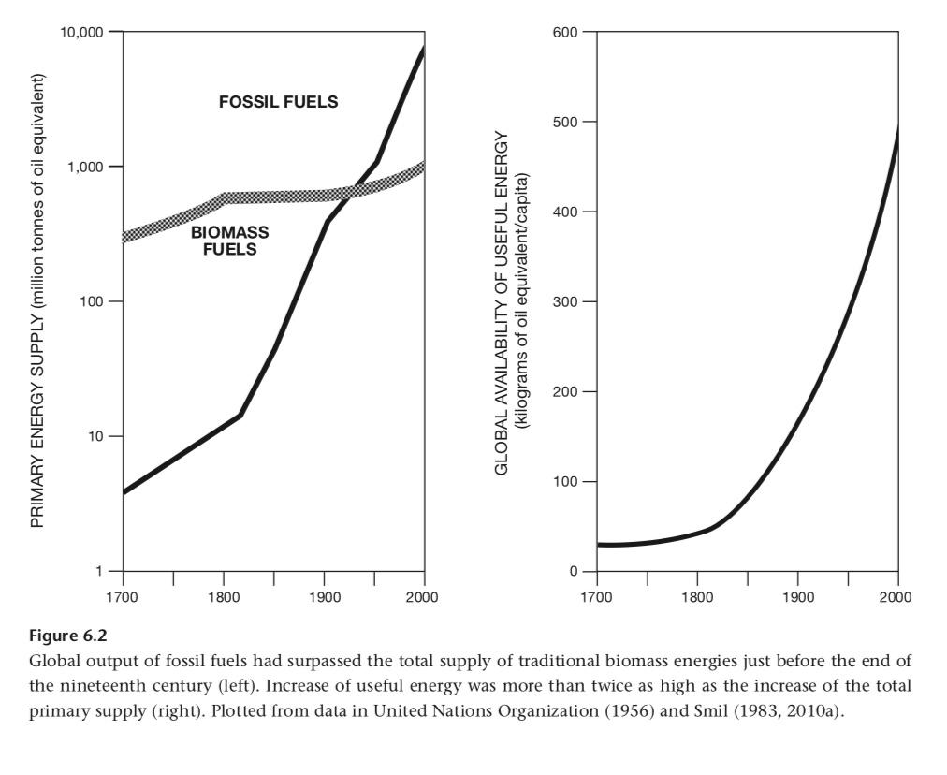

Foraging societies at 5-7 GJ/capita. New Egypt at 12. Early Rome at 18. Transport, shelter, clothing, etc.

Increase in per capita energy use in early civs is also under appreciated.

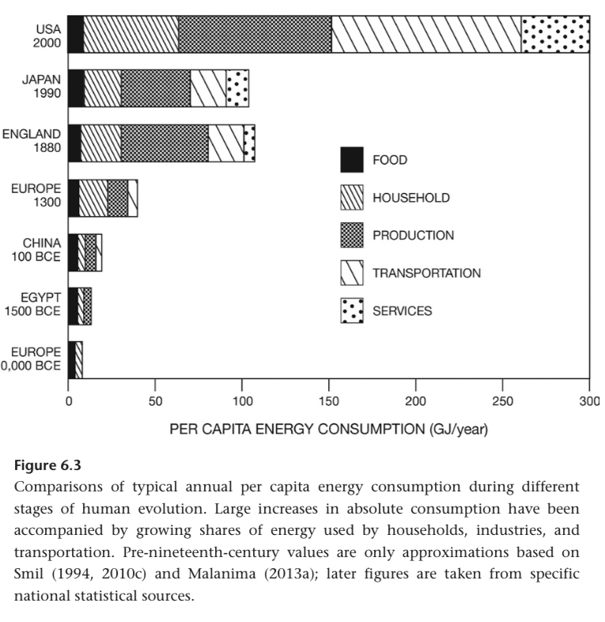

England 60 GT/capita in 1820. Exponential thereafter.

While England 2.5x 1820-1910, Italy only did 20%.

Roman energy was 45% food and fodder. 1960 US was <2% food and fodder.

Peak power command by a single person increased from horses to jer engines. 5 kW to 30 MW.

Accidents got worse potential. Automated monitoring solves this. Japanese rail system is integrated with seismic monitoring to slow trains before earthquakes reach them.

Electricity grew faster than energy during 1900s. 3% CAGR.

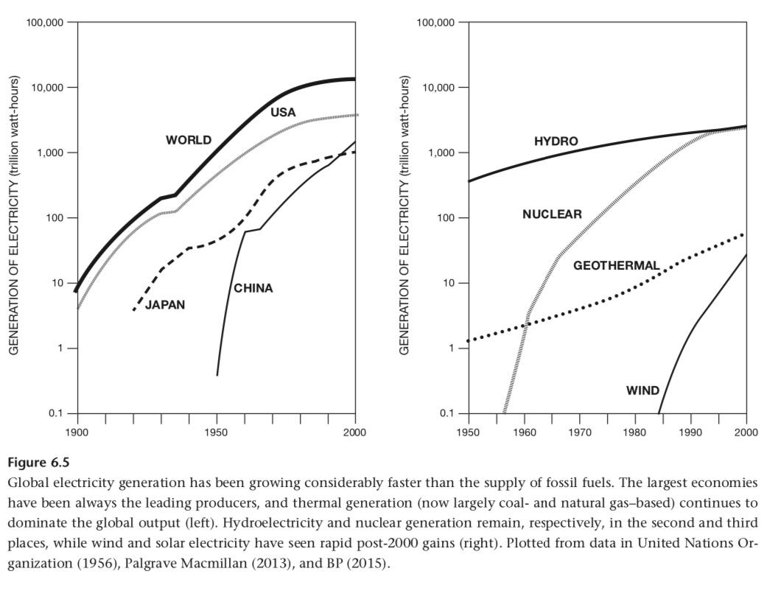

Even given inequalities, there are many universal improvements. He says.

First American tractor factory was 1905.

Power lifts, diesel engines, and rubber tires in 1930s.

Mechanisation proceeded slowly in Europe until 1950. Didnt take off in Asia and Latin America until 1960s.

Hours of labour per tonne of grain decreased. Good way to think about it.

Agriculture share of labour 2015: 1.5% US, 5% Europe, 30% China.

Liebig’s law of the minimum: the nutrient in the shortest supply will define the yield.

NPK are the three required micronutrients.

1842, John Bennett Lawes introduced treatment of phosphate rocks by dilutes sulphuric acid to produce ordinary superphosphate. Afterwards, many large phosphate deposits were discovered.

Potash (KCl) was mined at many sites.

So we have P and K.

Chilean nitrates were discovered on 1809.

Cyanamide process produced calcium cyanamide.

Birkeland-Eyde process, 1903 was the electric arc nitrogen oxide process.

Haber and Bosch!

The first practical use of Haber Bosch was not fertilisers but explosives in WW1.

By 1960s, a third of American farmers didnt use any synthetic fertilisers.

The first coke based Haber Bosch synthesis at BASFs first commercial plant required 100 GJ/t NH3 in 1913.

After 1950, bar gas based processes lowered it to 5” GJ/t NH3.

High pressure reforming of steam and better catalysts got to 40. Then to 27 around 2000.

Stoichiometric requirement is 20.8 GJ/t.

2015 average was 35.

Most farmers don’t apply ammonia, but liquids and solids. Urea is 45% nitrogen and solid.

Total energy cost of Ammonia to Urea is 55GJ/t N.

Worldwide, nitrogenous fertilisers use 1% of global energy.

Western nations could lower meat consumption and eat the feed crops if Haber Bosch suddenly disappeared. Africa could not.

70% of Chinas nitrogen is synthetic.

Mining of potash required 10 GJ/t K. Phosphatic fertilisers require 20 GJ/t.

After WW2, herbicides and pesticides took off.

During 1900s, irrigated farmland 5x’d. Now 18% of global farmland is irrigated. 70% of this is in Asia.

Sprinklers are actually far more efficient at applying water to crops. And more expensive. Now this is an interesting analysis to do!!

During 1900s, global population 3.7x.

During 1900, energy subsidy per unit area farmland 90x’d.

“A whole generation of citizens thought that the carrying capacity of the earth was proportional to the amount of land under cultivation and that higher efficiencies in using the energy of the sun had arrived. This is a sad hoax, for industrial man no longer eats potatoes made from solar energy, now he eats potatoes partly made of oil.”
- Howard Odum, 1971

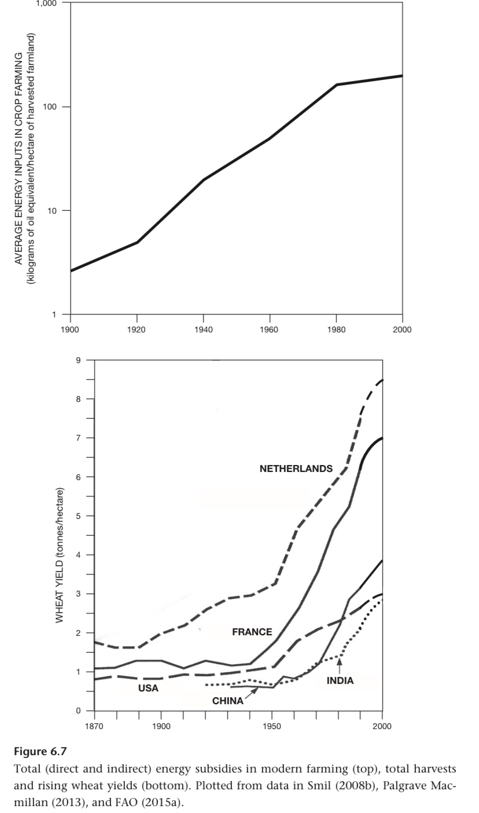

Hybrid wheat was introduced in the 1930s. Short-stalked wheat and rice in the 1960s.

2000, global food supply of 2,800 kcal/captia.

30-40% of food is wasted at the retail level. 75% overproduction of food.

50-60% of grain is fed to domestic animals.

Feed:meat ratio:
Chickens 3:1
Pork 9:1
Beef 25:1

This is also a function of the meat:live weight ratio:
Chicken 0.65
Pork 0.53
Beef 0.38

China is at 3,000kcal/capita.

Central drives using leather belts and line shafts were replaced by insidiously machine electric motors.

A money economy and mobility of labour and capital fostered growth of migration and banking.

Proto-industrialisation was distributed cohtbru side production. Centuries before coal industrialisation in Europe and Asia at notable scale. Cottage production.

Carburisation of wrought steel into Indian Wootz steel, was distributed in India for mass export to the Persian and Ottoman empires.

From 15th-16th centuries, materialism starts to be seen. Going out to eat Sushi in Japan, collecting art, going to theatres. This was a driver for industrialisation.

1851 British census showed more craftsmen than factory workers and blacksmiths than iron workers.

Belgiums industrialisation had more focus on metallurgy and less on textiles.

Industrialisation patterns were not uniform.

The Netherlands with their great finance and empire lands fell behind poorer but coal rich Belgium in terms of industrialization.

Coal wasn’t. Required, but it was an accelerant.

In 1901, Japans first steel works. 48 years after it opened to the world.

Inexpensive and reliable mechanical energy meant more complex designs could be done.

High lrsssure boilers and pipes production started after 1810.

Rails lcoptnivws and wagons in 1830, water turbines and screw propellers in 1840, iron hills and submarine telegraph cables after 1850.

Commercial methods of making inexpensive steel: Bessemer process, open hearth furnaces.

1871 England had 24% of workers on muscle power jobs. on 2011, 8%. Smaller delta than expected tbh.

Frederick Winslow Taylor spent 26 years starting in 1890wua torching all key variables in steel cutting. Reduced it to a. Simple set of slide rule calculations, wrote a book and insights are still used today.

Electricity is reliable, can be converted into light, heat, motion c or chemical potential. Extremely precise. Clean and silent at the point of consumption.
Control of power at individual work spaces couldn’t be doe with centralised transmission. Also prone to cracking or transmission failure and frictional losses.
Frederick Winslow Taylor’s main concern was wasted labour. He wanted efficient allocation of physical exertion. He opposed excessive quotas.
“If a man is overtired by his work, then the task has been wrongly set and this is as far as possible from the object of scientific management.”
Bethlehem Steel fired Taylor in 1901.
Japanese success has focused on eliminating unproductive labour and an uneven pace of work and encouraging workers to improve production processes.
Reduce non value adding activities!!!!!!!!
Your purpose in life is to reduce non value adding activities! (This stems from increasing net value addition)
Three decade transition from steam and water powered drives to electrical. Installed mechanical power in US industry 4x’d. Capacity of motors increased 60x.

Mechanical shafts were on the ceilings.

Fords assembly lines were rigid moving conveyors. Japanese assembly lines rely on just in time delivery of parts to workmen.

Electricity allows electrolytic reduction of aluminium oxide in an electrolyte. Electricity was also required for carbon fibre? Also, it’s required for micromachining.

Steel is 20x aluminium copper zinc and lead.

A South Korean blast furnace produced 17000 t steel/day!

1k per day reached before WW2. Bell rediesnges the blast furnace is 1840 to get 250m3, now we’re at 6000.

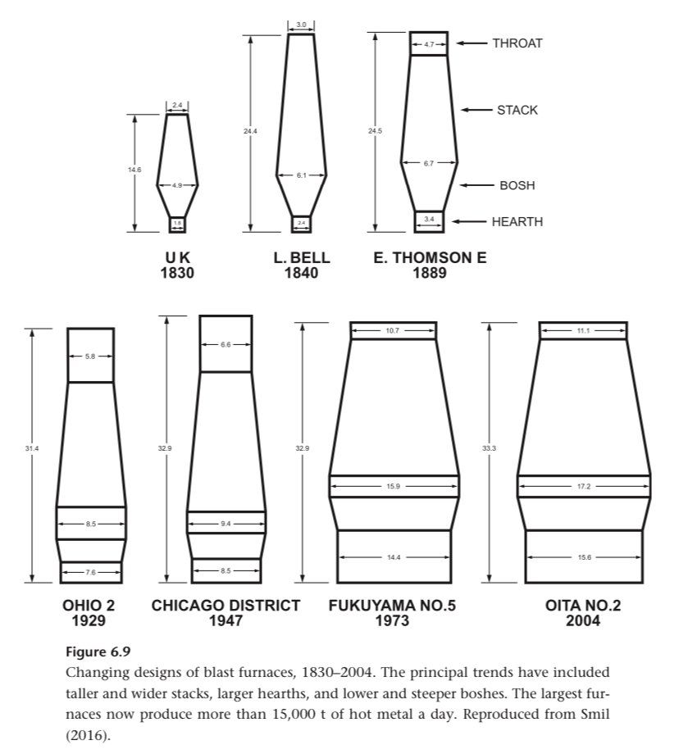

Blast furnaces require ~10Mt per year. 5 Mt ore, 3 coal, 1 flux materials, 0.5 steel scrap.

They run for 10-20 years continuously before the refractory brick interior and carbon hearth are relined.

Coke fueled iron smelting:
1750, 1-1.5 GJ/t
1900, 55
1950, 30
2010, 12-15

Coke consumption declined from 1-15 t/t metal, to 370 kg/t Japan and 340 kg/t Germany.

Early Bessemer furnaces turned 60-70% of iron into steel. Open hearth furnaces did 80%, BOF 95%, electric arc 97%.

Metal is continuously casted now instead of using ingots that requires reheating.

1900, 75g/capita. Now 225. Increasing!

Most improtsnt nonferrous metal innovation was aluminium smelting.

Aluminium isolated in 1824, economical process for large scale production in 1866.

Electrolysis of aluminium oxide requires 6x the energy to smelt iron. Initially, 50 MWh/t in 1880, ~16 MWh/t in 1990.

Aluminium began displacing steel bodies, then WW2 aircraft.

Aluminium displaces steel for high strength and light weight. Titanium takes over for high temperature (supersonic).

Titanium production is 3x as energy intensive as aluminium.

1977, GM Oldsmobile was the first car with an ECU controlling spark timing.

He’s comparing lines of code now. And he calls it misleading! Yes!

Most high end cars in 2015 had 100 networked ECUs.

Cars used to be mechanical assemblies and are now mechatronic hybrids.

I should plot crossing time across the Atlantic. 6-8 hours, days, weeks : now, 1900, 1700.

1847, first British train ran at a mile a minute (96 km/h), briefly on a scheduled run.

Commuter rail lines were what first allowed suburbanisation.

Trains were a monsterously importsnt invention. The world shrunk.

American rail construction iron began in 1834 in Philadelphia. By 1860, they 3x’d Britain. 1900, 10x.

Russian Siberia to Vladivostok transcontinental link started in 1891, completed 1917.

Post WW2, electric trains are the most improtant innovation. First in Japan in 1964 at 250 km/h.

US levels of car ownership in 1920 was only reached in Europe and Japan in the 1960s.

In 2010, Chinese car sales surpass US.

Autobahn in 1930s. US interstates in 1956.

In Autumn 1933, Hitler set the specifications of the people’s car. 100kmh, 7 L/km, space for 2 adults and 3 children, air cooling, cost below 1000 Reich marks.

Ferdinand Porsche had the car ready in 1938. The war meant no civilian production.

Major Ivan Herst saved the factory in 1945 and civilian production began. What a story that must be!

Production in Germany stopped in 1977, continues in Brazil until 1996 and in Mexico until 2003. They made 21 million.

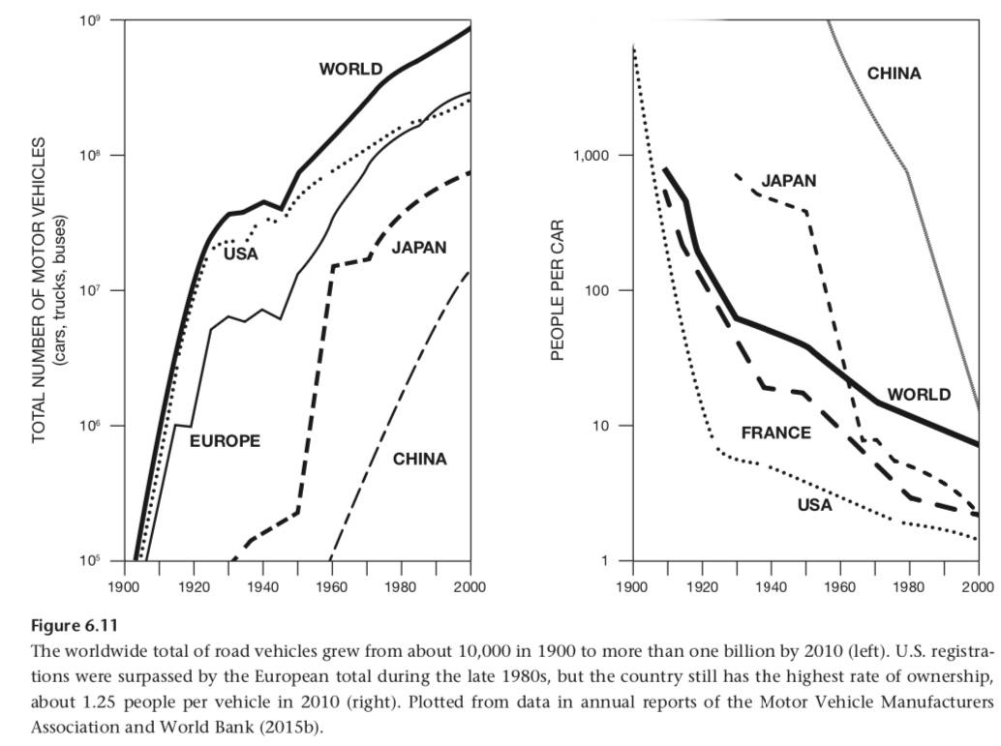

“Boulding’s (1974) analogy of a car as a mechanical steed turning its driver into a knight with an aristocrat’s mobility, looking down at pedestrian peasants (and making it almost unthinkable to rejoin them), is hardly exaggerated

In the US, 90% or cars are sold on credit.

1.3M deaths and 50M injuries annually due to cars.

Affluent countries' cars have a lifetime of 11 years. Poorer countries, 15 years.

Trucking was first important in the US in 1920 for moving farm products.

In some countries trucking means railways are not developed, eg. Brazil.

The first steam ships only matched the speed of sailing ships on good winds.

In the late 1840s, the fastest trip was 10 days. In 1890, 6 days was the norm.

Wooden hulls were limited to 100m, steel doesn’t have this limitation.

By 1890, steamships carried 500k passengers per year to New York.

In 1957, airlines carried more people than ships.

Suez Canal completed in 1869, boosting steamships early on.

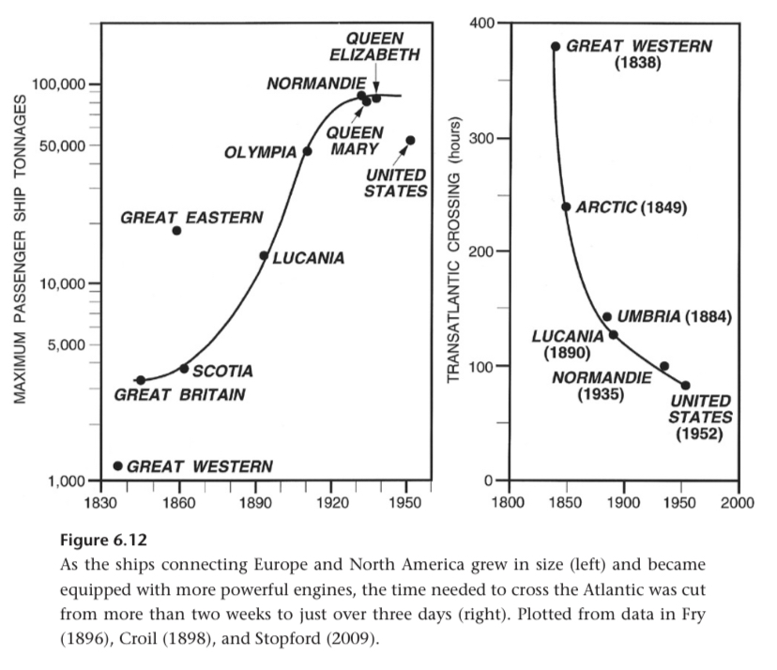
That’s an s curve and that's an exponential decline to an asymptote!!!!! Potentially useful for a blog post, appendix to S-curves.

Ashcexules itnernational air flights started in 1919 between London and Paris at <200 km/h.

Regular transoceanic aircraft links happened just before WW2 in Mar 1939 with Panam’s Clipper going from SF to Hong Kong in 6 days.

707 first flight was 1957, in service since Oct 1958. Followed by the 727 which was put into service in Feb 1964.

8600 737s have been sold as of 2015. Best selling in history.

During the 1960s, McDonnell Douglas (DC-9, triple-engine DC-10), General Dynamics (Convair), Lockheed (Tristar), and Sud Aviation (Caravelle) introduced their own jetliners. Now we have the duopoly.

William E. Boeing founded his company in 1916. Airbus setup by Germans and French later joined by British and Italians.

The A300 launched in October 1972.

A319, A320, A340 serve various types of flights. My god are all these planes from the 70s and 80s?

In 2000 Airbus surpassed the number of planes sold by Boeing.

2001 to 2015, both produced ~6-7 (exclusive) thousand airplanes, multi year back logs.

Canadian Bombardier and Brazilian Embraer have been enlarging their jets.

Russias Sukhoi Superjet, Chinas Commercial Aircaft corporation of China, and Japans Mitsubishi are entering the market.

Dallas-Sydney and Johannesburg-Atlanta are 17 hour flights.

300 flights per day between Rio and Sao Paulo. 200 between NY and Chicago. Define flights here, how many passengers?

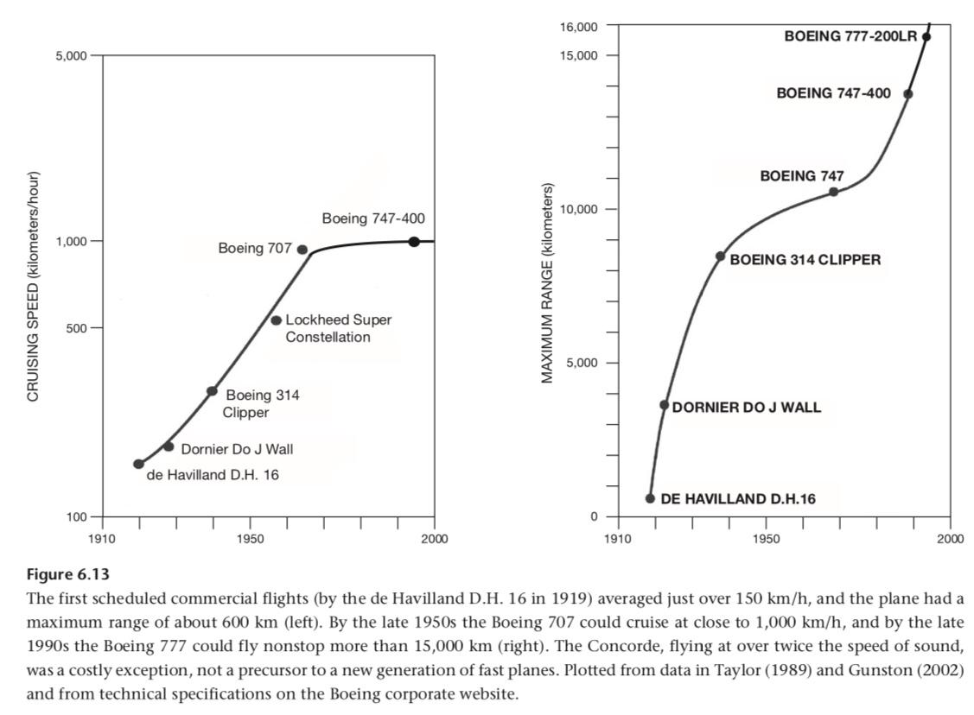

Gutenberg press could make no more than 240 impressions per hour.

First steam powered press sold to the times in 1814 could do 1100 impressions per hour.

First rotary presses of the 1840s got to 8000.

First commercial telegraph in 1836. Decades of experiments.

Reliable source of electricity required, Alessandro Volta's battery. Morses coding system too.

1851 saw the first undersea English Channel link. Atlantic in 1866.

In 1900, multiplex wires carried millions of words per day.

Alexander Graham Bell patented the telephone in 1876, just hours before Elisha Greys filing.

First cross America link in 1915, cross Atlantic cable in 1956. Before that was Radio links since the 1920s but weren’t cheap or reliable.

Kodaks first inexpensive box camera in 1888.

First public short movies played by the Limers brothers in 1895. The first sound movie was called The Jazz Singer in 1927.

James Clerk Maxwell formulated the theory of electromagnetic radiation. Heinrich Hertz generated electromagnetic waves in 1887. Around 1900, first signals crossing the English Channel or the Atlantic. 1897, cathode ray tube invented.

Define telephony.

Scheduled radio broadcasts in 1920. BBC did the first television broadcasts in 1936.

Early computers with vacuum tubes had no commercial use. British Mark, Harvard Mark 1, and the ENIAC.

Julius Edgar Lilienfeld filed the patent for the field effect transistor in Canada in 1925. He however did not make it. At Bell Labs in 1947 they really reinvented the transistor, but built the first one.

Claude Shannon! That’s why it’s called Claude!

He did research into the quantitative energy cost of communication in 1948. Set a limit, and suggested we could get towards it.

Texas Instruments marketed the first silicon transistor in 1954.

At TI and Fairchild simultaneously ICs were invented.

Robert Noyce at Fairchild wanted to put circuits on a single piece of silicon so that interconnections between devices could be done during this manufacturing step.

His 1959 patent described vacuum deposited metal on an oxide semiconductor layer.

In 1966 both companies came to an agreement to share the technology and suppliers.

Noyce died in 1990, Kilby of TI lived until 2000 to get a Nobel prize.

In 1965, the number of transistors on a chip doubled from 32 to 64? Moore stated it would double every year. In 1975 he relaxed it to every 2 years.

First microprocessor controlled device was a Busicom (Japanese company) calculator with an Intel chip.

Only a few sold before they went bankrupt in 1974.

Intel bought back the rights to the processor before they went bankrupt. How important was that?

Then, 3x4 mm Intel 4004 first universal microprocessor with 2250 MOSFETs. $200, 1971. 60k operations per second, equivalent to room sized ENIAC of 26 years prior.

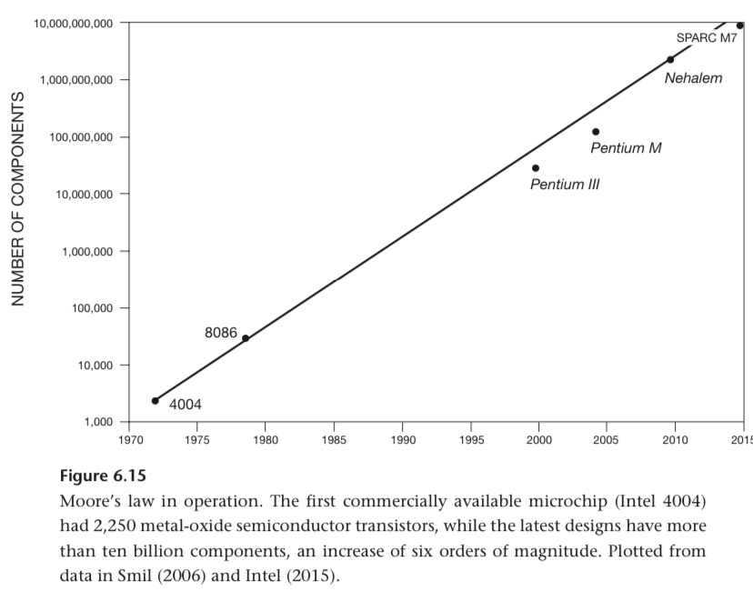

The mouse and GUI were invented at Xerox in the 1970s.

Apple II was 1977, IBM PC in 1981.

1983, 2M PCs owned, 53M in 1990. Another exponential there.

JCR Licklider, first director of ARPA, proposed communication using computers on 1962. ARPAnet in 1969 between various universities.

In 1972, Ray Tomlinson chose the at sign for locator symbol of email addresses.

In 1989, when an expanded ARPAnet ended operation, it had over 100,000 hosts.

In 1990, Tim Berners-Lee created the hypertext based World Wide Web at CERN in Geneva to organize online scientific information.

Netscape was in 1993, early browsers made the internet far easier to use than predescesor.

Apparently cheap intercontinental calls were made possible by GEO sats.

Cell phones demonstrated in 1973 and Motorola began selling early ones in 83.

A phone weights 100x less than a car and has 100x less embodied energy (1 GJ vs 100). 2B phones per year vs 72 M cars. 2 year phone lifetime vs 10 year car. They net out to 1 EJ/year and 0.72 respectively. This is only for production, but more energy is spent on phones.

A phone required 4kWh per year. Usage electricity is 3% of its embodied energy cost. For a car Thats 4-5x it’s embodied energy cost.

W. K. Roentgen discovered X rays in 1895.

“To talk about energy and the economy is a tautology: every economic activity is fundamentally nothing but a conversion of one kind of energy to another, and monies are just a convenient (and often rather unrepresentative) proxy for valuing the energy flows.”

Do tell about when it’s unrepresentative!

“The flow of energy should be the primary concern of economics.”
- Frederick Soddy

Energy flow is not a great measure of intellectual activity. Higher brain metabolic rate doesn’t necessarily equal more innovations.

GDP growth decoupled from energy usage? Interesting data to look into.

The US economy became less dependent on oil over time. OPEC 70s price rises, increased efficiency, Nat gas, etc. In 2014 the US economy required 62% less oil to create a dollar of GDP than in 1970.

When oil gets cheaper there’s an incentive for larger less efficient cars.

In 2014, in G7 countries, taxes were 47% the cost of oil, 39% going to the producers.

10% of Saudi governemnt expenditures go to oil subsidies. The Chinese governemnt subsidises coal so much that prices are fixed below production cost??

British economy 10x’d between 1800 and 1900. 20-60% growth per decade.

1950 to 1973 was the greatest period of growth humanity ever experienced.

Steady oil prices were required for this. Then OPECs 1973-74 oil price raises increased American prices 60% and elsewhere even more.

Another round of increases in 1979 when the Iranian monarchy fell.

Low oil prices in the 1990s meant another period of growth, then 2008.

When using purchasing power parity to compare inflation adjusted gross world product, you see correlation between this and energy.

1900 to 2000, all primary energy (without processing losses and non fuel uses of fossil fuels) rose 8x. The economy rose 18x.

Elasticity of <0.5.

20th century, Japanese economy grew 52x.

Energy intensity is declining.

“The rise in absolute energy consumption required to produce higher economic outputs hides an important relative decline. High-income, high-energy mature economies have a significantly lower energy intensity (energy per unit of GDP) than they had during earlier stages of their development.”

Highest British energy intensity was directly after the steam engine growth of 1830-1850. US peak before 1920. China in 70s. India in 2000s.

Chinese energy intensity fell 75% from 1980 to 2013. Low efficiency post Mao processes and modernisation.

Basic infrastructure requires a lot of energy, conversion efficiency increased, and service economy requires less energy per unit gdp.

“A decoupling of economic growth and energy consumption during early stages of modern economic development would defy the laws of
thermodynamics.”

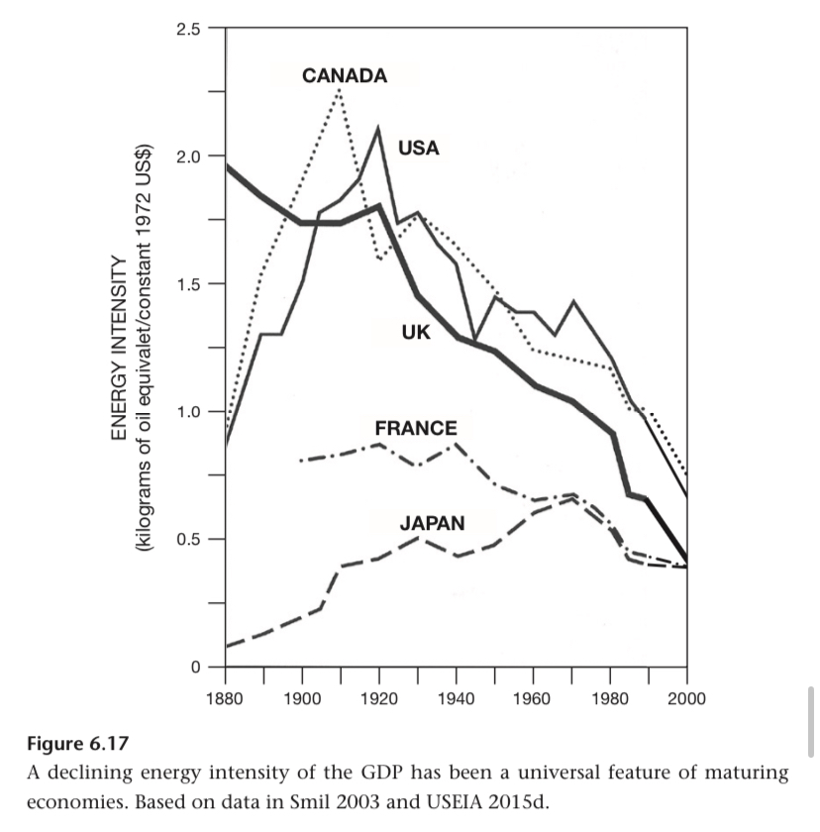

Being fat is an undesirable physical manifestation of high energy use.

Urbanisation has been a source of innovation, opportunity, and increased standard of living.

Rome in 100 had a population of 500k.

Baghdad in the early 9th century, 700k.

Changan (capital or Tang dynasty), 800k.

In 1800, 10% of Europe's population lived in cities.

Croplands supporting a city had to be 50-100x the size of the city.

Depending on climate and industrialization, cities require 15-150 W/m2. Coal and crude oils are extracted at 1000-10000 W/m2. So a fossil fueled city required 1/7 to 1/1000 its area to get energy.

“While traditional cities had to be supported by the concentration of diffuse energy flows harvested over large areas, modern cities are supplied by the diffusion of fossil energies extracted in concentrated fashion from relatively small areas.”

27 mega cities in the world (>10M pop) contain 7% of global population, consume 9% of electricity and 10% of all gasoline.

In 1900, 15% of people lived in cities. In the worlds largest coal producing nations, urban population was far higher. 70% in the UK, 50% Germany, 40% US.

Bettencourt and West: when the population of a city doubles, economic productivity increases 130%.

Superlinear scaling. (I think this means slope >1 on the Econ vs pop chart.)

Compare urbanisation to the alternatives and they are often no less objectionable.

He points out that the decline of communism is partly to do with the better lives that those under capitalism could live.

The richest used roughly 20-40x more energy than the poorest, I think this is quartiles.

Per capita is limited because it doesn’t tell you about the distribution. Eg. USSR, North Korea, Pakistan the military use a disproportionately large share of energy.

30% of Chinese energy goes into industry. Very high compared to other nations.

France 1954 Census:
60% of households had running water, 25% indoor toilet, 10% bathroom and central heating

France mid 1970s:
90% has refrigerators, 70% had bathrooms, 60% central heating and washing machines, 75% with a car.

China has the world's largest network of interprovincial freeways. Shit!!

Electricity decreased housework for women. Standards for hygiene and social expectations rose with better education, so initially women’s work got harder.

Caro’s LBJ biography illustrates this. In rural Texas energy (wood and kerosene) were in good supply, but no electricity. Ironing with heavy hot metal, carrying water, grinding feed, sawing wood. This fell mainly on women.

Farms described there required 300t water / year. >60 8 hour days of walking for this water per year.

“Not surprisingly, nothing could have been as revolutionary in the life of these people as the extension of transmission lines.”

Refrigeration is 10% of electricity use in rich nations.

Early 1900s, electrical appliances start becoming available. GE sold electric irons, fans, immersion water heaters, etc.

Air conditioner patented in 1902, first non industrial uses in the 50s.

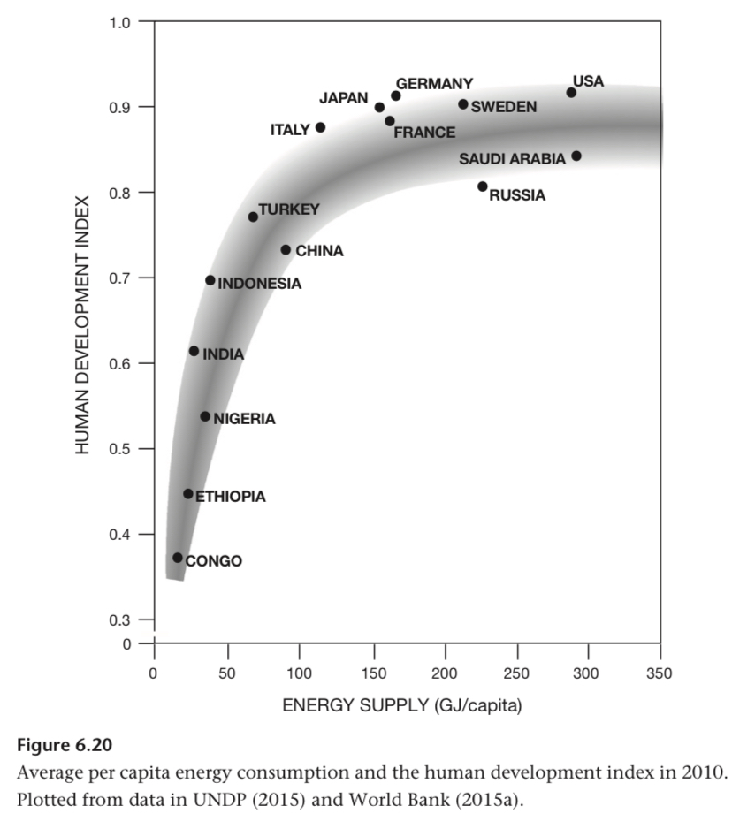

You get diminishing returns in human development index with energy supply.

The Human Develop Index combines life expectancy at birth, adult literacy, educational enrolment, per capita GDP.

As average family sizes decline, US home sizes increase. Size has doubled since the 50s.

Again, the lack of American adulation so achievements compared to others is strange.

Adams, 1975:
“when “more energetic processes and forms enter a society, control over them becomes disproportionately concentrated in the hands of a few, so that fewer independent decisions are responsible for greater releases of energy.””

The Spanish conquest of the Americas led to tens of millions of deaths. Napoleon, 2.5M.

There was the great leap forward but also the cultural revolution that caused tons of destruction.

Concentration of power in the communist nations led to a disproportionate amount of death. Worth applying this to the Prussians in WW1, Spanish, Napoleonic, and other conquests as well.

This is part of the proof I needed for my blog post.

Organization of Petroleum Exporting Countries. OPEC

OPEC decisions are made by a small number of individuals. It was their decisions that caused 5x in prices in 73-74 and 4x in 79-80. High inflation and reduced economic growth.

Another situation of concentrated power leads to terrible results for the people.

What was the impact and cause of the OPEC price raises after 1971?

IEA and western nations organized energy sharing agreements after the OPEC raises. France focused on Nuclear too. Strategic reserves created around here too.

In July 2008 new record oil price of $145/barrel. December, $30.

China became an oil importer in 1994.

When the US became a leader in oil production again from shale and hydraulic fracturing, the Saudis this time didnt reduce production to prop up price. Instead, they wanted to keep global market share.

The Persian Hulf contains 12 of the worlds 15 largest oil fields. 65% of the worlds liquid oil.

Soviets tried to invade northern Iran in 1945-46.

Around operation Desert Storm, Iraq increased oil production and had 20% of the worlds oil rare sea. Saudi had 25% and their production was threatened.

Light has been a symbol for ages. First the idnsturialists, the Nazis used walls of light to awe during party rallies, etc.

“Lenin summarized his goal in a terse slogan, “Communism equals the Soviet power plus electrification,””

Mass tank manufacturing is not the right response to terrorists obv. Misallocated resources.

“[inefficient allocation of resources] has marked the history of modern weapon procurement.”

Two principle classes of weapons during the American civil war and napoleonic wars: infantry muskets and 12 pound guns.

Arrows and bows had kinetic energies of 10^1 joules. Some heavy cross bows 10^2 exactly.

Bullets from muskets and early rifles were 10^3.

Tanks are 10^6 J.

Missiles are meant to have explosives, not damage through kinetic energy. But V1 missiles that failed to explode had 15-18 MJ.

The World Trade Center Towers were designed for a 707 collision at 80 m/s (eg on landing at LaGuardia).

The 767 was 15% heavier and impacted at 200 m/s, 7x kinetic energy.

50t of kerosene burned, 2 TJ. 46% of the energy of the collision was spent on the outer columns.

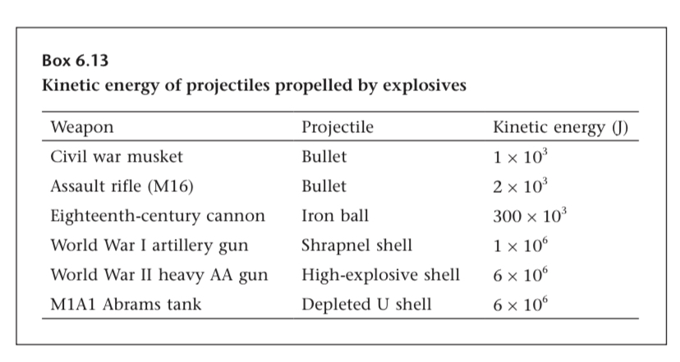

Explosives are self-oxidising!!!

Nitroglycerins first made in 1846.

Alfred Nobel mixed nitroglycerins with Diatamacious earth (slightly porous) make dynamite, and made the first practical igniter.

Gunpowders detonation velocity is a few hundred meters per second. Dynamite is 6800m/s, trinitrotoluene’s 6,700m/s.

cyclotrimethylenetrinitramine, most powerful ore nuclear explosive was 8800m/s.

AFNO is 94% NH4NO3, 6% fuel oil. Can be sourced from ammonium nitrate. Suicide bombers.

1860s, best field and naval guns had a range of 2 km. Better propellants and steel got to 30 km by 1900.

Steam turbines was required for larger iron battleships like the HMS Dreadnought.

First purpose built aircraft carriers came in 1902.

The first Modern field gun was a French 75mm cannon. Its shells were filled with 700 g of Pictor acid for an explosive energy of 2.6 MJ.

Panzer shells were 4 MJ.

The largest Nuke of the first three was 3.8GJ. Wow what a minority if it only takes ~1300 shells to equal that.

Nope! The largest bomb carried by the B 17 was 3.8GJ, he didn’t mention nukes I just assumed that.

Mar 9-10 1945, 334 B-29s above Tokyo dropped bombs at 600-750m altitude. 230 kg cluster bombs with 39 M-69 in incendiary bombs inside. Filled with polystyrene , benzene, gasoline. 1,500t of incendiary compounds dropped total. 60 TJ. Similar to the energy of the bomb on Hiroshima. Ok now that energy makes sense.

Around 18 PJ was released from the burning afterward. 300x the bombs themselves.

Hiroshima was 63 TJ. ~50% blast, ~35% thermal radiation.

8:15 am, august 7, 1945.

Nagasaki was 92 TJ.

Tsar Bomba was 209 PJ.

1 ton TNT = 4.184 GJ.

Victor Weisskopf (1983, 25) noted:
“Nuclear weapons are not weapons of war. The only purpose they can possibly have is to deter their use by the other side, and for that purpose far fewer are good enough.”

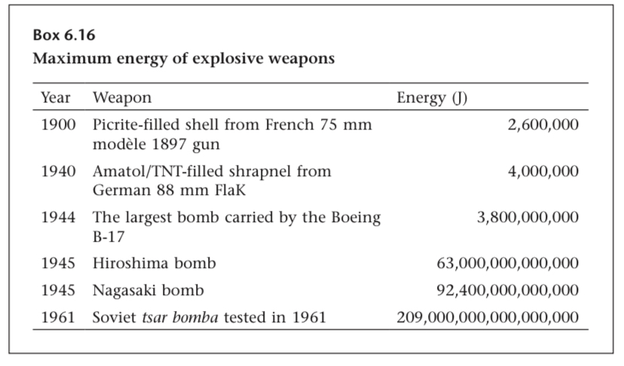

SWU = separative work unit (uranium refining term)

227 SWU needed to produce a kg of weapons grade uranium.

9 GJ/SWU in old gaseous diffusion process, 180 MJ/SWU using modern processes. Modern kg requires 41 GJ/kg.

Nuclear weapons programs are energy intensive! Would like to look into how energy intensive in reality.

Ordinary steel could be made for 20 MJ/kg. Speciality steels could be 40-50 MJ/kg.

Depleted uranium is used for armour piercing shells and enhanced armour. What is depleted uranium?

Aluminium, titanium, and composites embody 170-250 MJ/kg, 450 MJ/kg, and 100-150 MJ/kg respectively.

On the order of 10x more than steel.

Abrams has a 1.1 MW gas turbine and consumed 400-800 L/100 km. large SUV is 15, Civic is 8.

Three refuelling planes. KC-10, KC-135, 767.

During the Gulf war 1300 aircraft flew 116,000 sorties.

At the start of WW1, Britain had 154 military aircraft. At the end they employed 350,000 and produced 30,000 planes per year.

When the US joined WW1, they had 300 planes none of which could carry machine guns or bombs.

Then, a few months later the US congress approved an appropriation of $640M (12B in 2015) for 22500 Liberty engines for fighters.

Q4 1940 saw 514 planes delivered to the USAF. 1941, 8723. 1942, 26,448. 1943, >45,000. 1944, 51,547.

America's aircraft production was the largest manufacturing sector of the war. 2M workers. 25% of all wartime expenditures. ~300K planes total. Compared to 117k British, 112 German, and 67 Japanese.

By 1944, US Canada Uk USSR were producing 3x as much combat munitions as Germany and Japan.

Two first modern wars with major powers were the Crimean war and Franco-Prussian war. Per 1000 armed forces, ~200 deaths. In WW1, 1500. WW2, 4000. This tells you the military to civilian ratio in the limit.

“wartime economic mobilization affects nearly all activities.”

In 2011 dollars, US expenditures:
WW1: $334B
WW2: $4.1T
Vietnam: $748B

Multiplying by energy intensity of the economy and with an extra bump bc military uses more energy:
WW1: 15% (1917-1918)
WW2: 40%
Vietnam: 4%

Peaks were 54% in the US in 1944 and 76% in the USSR in 1942 (similar in Germany 1943).

19 9/11 hijackers were armed with box cutters, all costs including flight lessons were $500k. He cites (bin laden 2004, 3) lol

On the order of 5% of US and Soviet energy from 1950-1990 was spent on nuclear weapons and associated activities.

Weapons grade uranium can be diluted using depleted and natural uranium for use in electricity generation.

July 1940, US export to Japan of aviation gas and machine tools was banned. September, scrap metal too.

Japan's conquest of Manchuria began in 1933, and conquest of China in 1937.

Neither Japan or Nazi Germans were motivated by energy in many of the conquests they undertook. Neither was the Korean war about energy.

Iraqi invasion of Kuwait threatened the Monarchy (Saudi or Kuwaiti?).

US import of Iraqi oil peaked in 2001 at 41 Mt. While Suddam Hussein was in control. This declined until 2015 at 12Mt (time of writing). <3% of US imports.

Ok but what share of US imports was Iraqi oil in 1990?

Hell yea Fracking!

“The verdict is simple: the United States does not need Iraqi oil, East Asia has been its largest buyer—so did the United States go into Iraq to secure Chinese oil supplies?”

“The conclusion is clear: broader strategic aims, whether well justified or misplaced, and not a quest for resources have led America into its post–World War II conflicts.”

Until the mid 1980s, the most pressing environmental problem seen by affluent counties was SOx and NOx pollution from large coal fired power plants and vehicles.

Depletion of the ozone layer was briefly the biggest problem, first observed in Antarctica in 1985. It was predicted in 1974.

Ozone loss is caused by CFCs. International treaty solved this.

1957 Hans Suess and Roger Revelle:
“human beings are now carrying out a large scale geophysical experiment of a kind that could not have happened in the past nor be reproduced in the future. Within a few centuries we are returning to the atmosphere and oceans the concentrated organic carbon stored in sedimentary rocks over hundreds of millions of years. (Revelle and Suess 1957, 19).”

1958, background CO2 measurements begin at Mauna Loa and in Antarctica.

Carbon sequestration requires 10 Gt/year to be effective.

Getting below 2 C requires immediately and worldwide shifting away from fossil fuels.

“some of those large new needs can come from renewable electricity generation, but there is no affordable, mass-scale alternative available for transportation fuels, feedstocks (ammonia, plastics), or iron ore smelting.”

Ah, but now there will be!

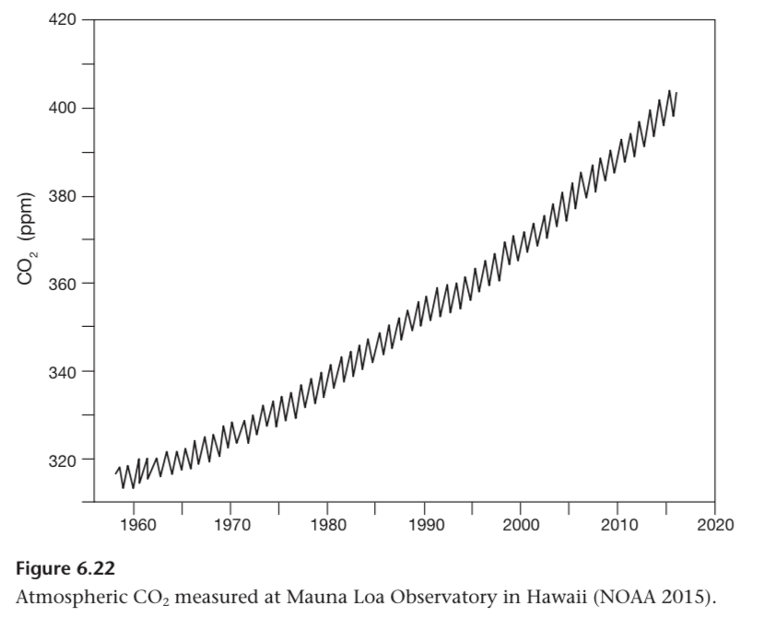

7. Energy in World History

We’re all energy transforming machines.

“All living systems are sustained by incessant improtsnt of energy. And this dependence necessarily introduces a number of fundamental constraints.”

“As the reach of services and products offered by these firms became truly global, former international differences in performance and reliability have been greatly reduced or even entirely eliminated.”

Excessive tree cutting was followed by soil erosion on vulnerable slopes destroyed conditions for sustainable tree growth.

“Destroyed conditions for sustainable forest growth”!!!

Long periods of diffusion required for new prime movers (remember ploughs). Inertia.

What is path dependence?

“As long as the established sources or prime movers work well within established settings, are readily available, and are profitable, their substitutes, even those with some clearly superior attributes, will advance only slowly.”

Liberty ships were not powered by new efficiency distal engines, but by oil fired boilers running 3 piston steam engines.

Steam turbine vs engine?

The Han Chinese took steps towards casting and the largest kiln was 3x8 meters.

Almost all manufacturing before the 1900s was artisanal.

This chart is a series of S curves! I need better raw data to show this! Note the S curves don’t reach 100% saturation. Blog insight.

The chart shows the dominance of human labour, some animal domestication, growth of wind and water mills, then steam turbines and liquid hydrocarbons.

Some steam engines are stil used, not all turbines.

Logistics was the constraint:
“The costs of distribution beyond a relatively small radius would have surpassed any economies of scale gained by centralized manufacturing.”

Piecemeal construction and repairs of Chinas Great Wall lasted more than 1,400 years.

In 1963, when tractor power was 12x draft animals, the US DOA stopped counting draft animals.

Han China was 207 BC to 220 AD.

The Han Chinese used coal in iron making, drilled for Nat gas, made steel from cast iron, curves moldnoard plows, collar harnesses, seed drills.

This book is just going in circles now could have made it at least 30% shorter without loss of total information.

By the time of the first great gothic cathedrals, the biggest water mills were 5kW. But the Romans were 2kW?

Late Medieval era saw better Chinese technology than European, as travellers attested. After the 15th century this changed.

Christianity had the criticism concept of the dignity of manual labour?

Circles.

In 1900 the west had 30% of global population and 95% of fossil fuel use.

2000, the west had <15% of global population and 50% of all commercial primary energy.

During the 1900s, western energy use 20x’d while its share fell.

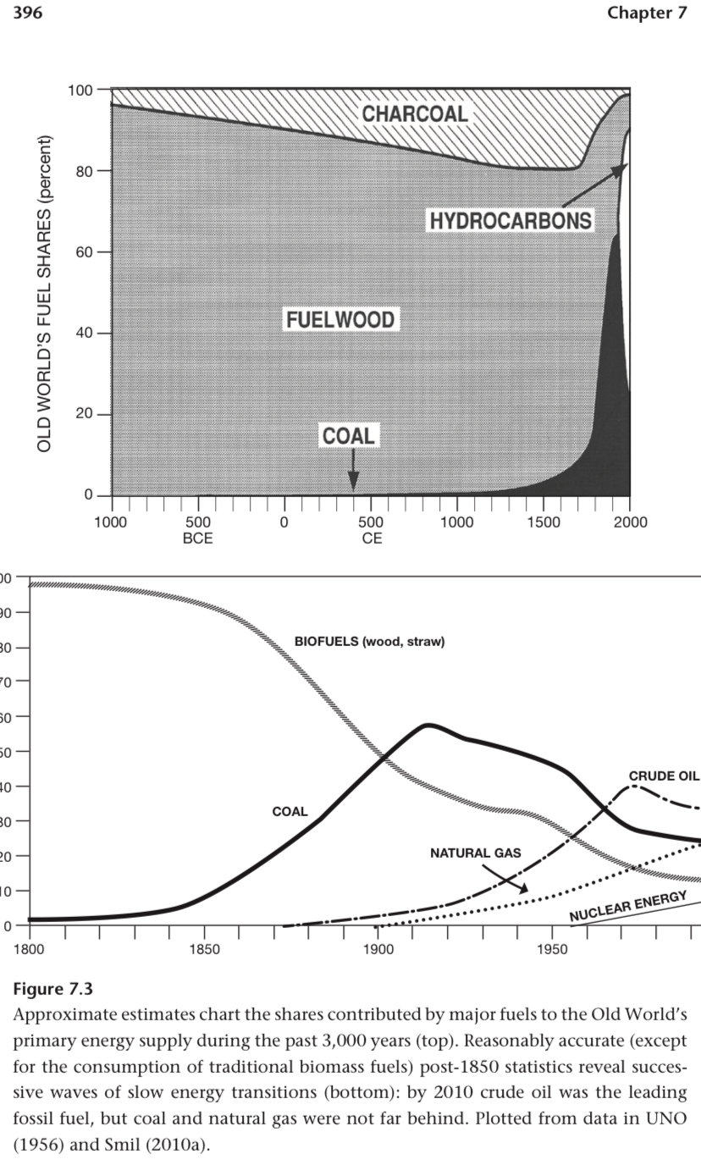

If I plotted this out I think I’d see an S curve:

“1840, 10% by 1855, 15% by 1865, 20% by 1870, 25% by 1875, 33% by 1885, 40% by 1895, and 50% by 1900 (Smil 2010a). The sequence of years needed to reach these milestones was 15–25–30–35–45–55–60.”

On the new renewable paradigm:

“Although the sequence of three substitutions does not mean that the fourth transition, now in its earliest stage (with fossil fuels being replaced by new conversions of renewable energy flows), will proceed at a similar pace, the odds are highly in favor of another protracted process.”

We’ll see!

Two factors he expects could accelerate the shift: nuclear and cheap energy storage.

Terraform is conquering it all:
“And even then we would still face the challenges of replacing billions of tonnes of high energy-density liquid fuels in transportation, and producing pig iron, cement, plastics, and ammonia without any fossil carbon.”

Maximum capacities of single units:
Human - 100W
Animals - 300-400W - 3000 BC
Horizontal water wheels - 5kW - 1000
Steam engines - 100kW - 1800
Water turbines - 10 MW - 1850 To 1910
Steam turbines - 1 GW - 1960+

What will come next?

Internal combustion engines have a far lower capacity factor than turbogenerators.

What does the turbo prefix mean there?

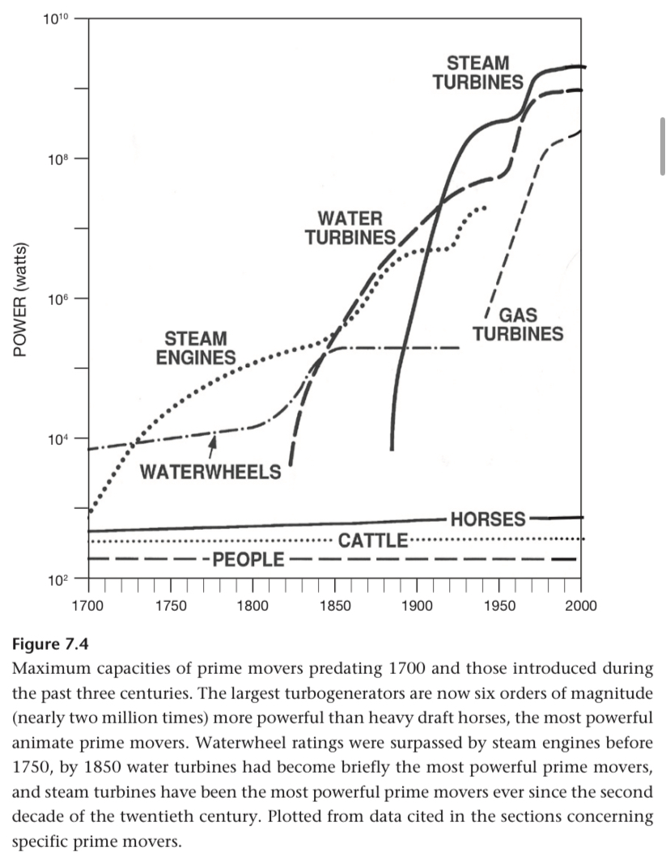

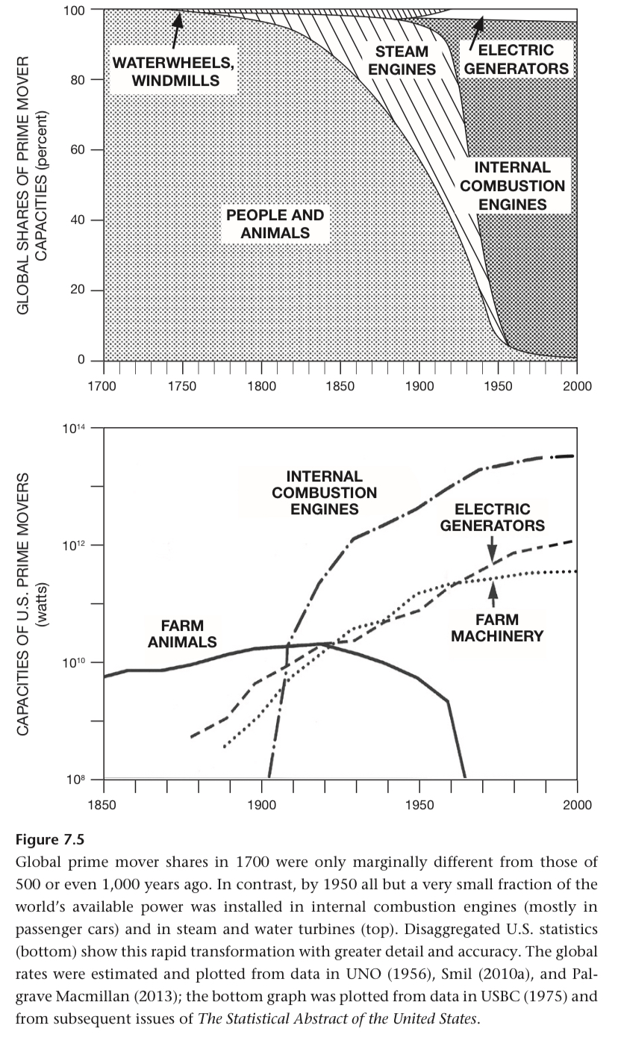

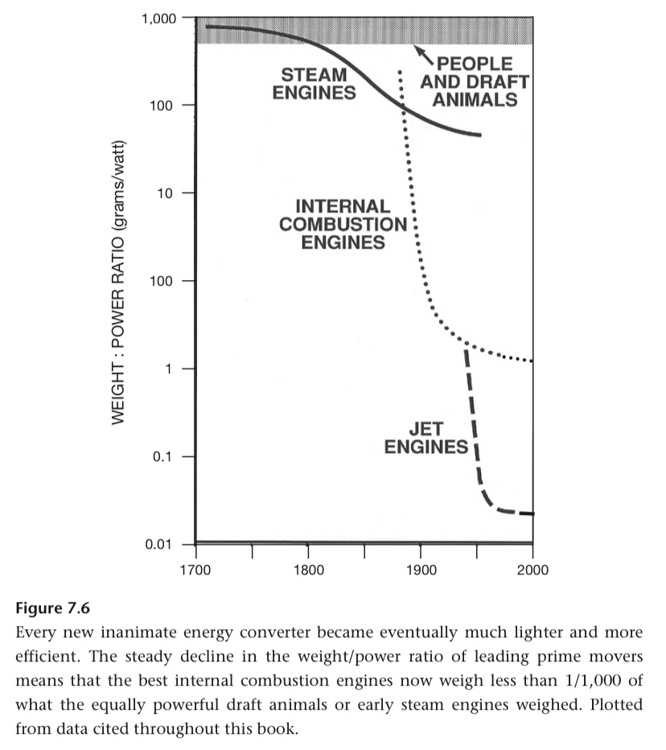

S curves!!

We’re nearing theoretical maxima for efficiency.

“The efficiencies of prime movers are limited by fundamental thermodynamic considerations. Technical advances have been narrowing the gaps between best performances and theoretical maxima.”

Turbogenerators are at 60% with the combined cycle. The best combustors are >97%, eg. Natural gas furnaces.

He’s on lighting again, circles.

Gas lights of the late 1800s were 0.15-0.3% efficient.

Osmium filaments in 1898 got to 0.6%! BASF really got all the Osmium?

Tungsten in a vacuum doubled that, then with an inert gas doubled again.

Luminous efficacies of various light sources (lm/W):
• Candle: 0.3
• Gas light: 1–2
• Early incandescent light bulbs: <5
• Modern incandescent lights: 10–15
• Fluorescent lights: up to 100
• Low-pressure sodium lamps: >200 (most efficient, yellowish, used for street lighting)
• Light-emitting diodes (LEDs): ~100 (suitable for indoor use, expected to exceed 150 soon)

Standard cruising speed of passenger jets is 880-920 km/h at 11km.

Antonov 225 can carry 250t.

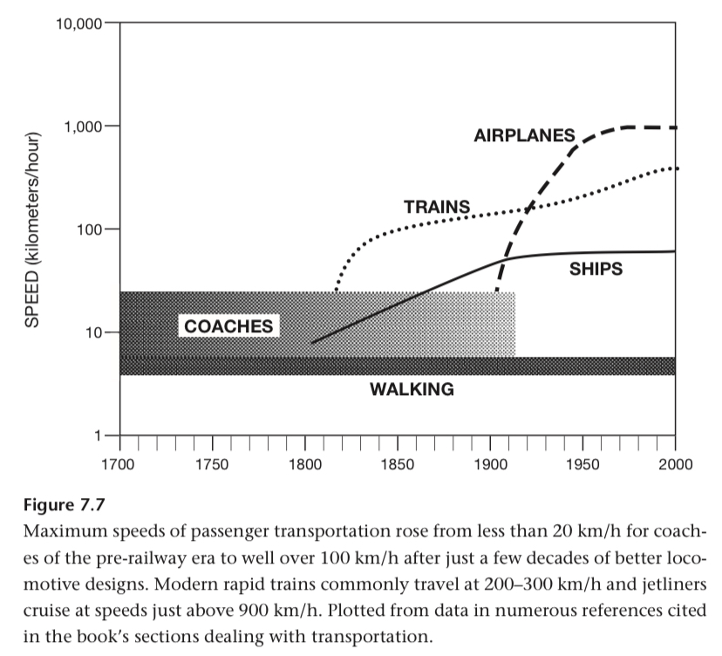

Volkswagen Passat TDI in 2012 set the record of 2,600 km on a single tank.

Ranges of projectile weapons:
- spears (10s of meters)
- Expert spear throwers (60m)
- Composite Bows / crossbows (500-700m)
- Catapults (200-500m)
- Cannons 1500 (1,400m)
- Largest field pieces 1900 (10s km)
- Bombers (6000km)
- Ballistic missiles

Primary energy flows: 1800, 650 GW. 2000, 12.2 TW. 20x over 2 centuries. While fossil fuel extraction 900 x'd.

US energy per capita 2.5x’d in the 20th century. Useful energy (efficiency) from 25 GJ/t (capita?) to 150.

Average light consumption in Britain went up 11,000x from 1750 to 2000.

75% decline in European energy prices in 1900s. Only? 83% in Britain and 33% in Italy. What? Was Italy cheap or is it now expensive.

Lighting declined in cost 4 orders from 1500 to 2000.

Meanwhile, in the US disposable income increased and efficiency increased. Useful energy decline in cost much more than primary energy. Affordability, not cost.

Fossil fuels are mostly subsidised by by ignoring externalities, low tax rates, etc.

2015, IMF put global energy subsidies at $5.3T, 6.5% of global economic output.

He says this is mostly from undercharging externalities. Now including traffic accidents.

“They spread both basic literacy and higher education (although the mass granting of all university degrees has diminished their worth).”

The abundance of uni resort degrees would not be possible without cheaper energy. Would be interesting to write this full proof.

Autarky!
“Fossil fuels and electricity have moved the world from a mosaic of economic autarchies and limited cultural horizons to an increasingly interdependent whole.”

Major economic upswings:
1787-1814: extraction of coal and stationary steam engines
1843-1869: mobile steam engines and iron metallurgy
1898-1924: commercial electricity and electric drives in factories

How many of these could I get data on to model as an S Curve?

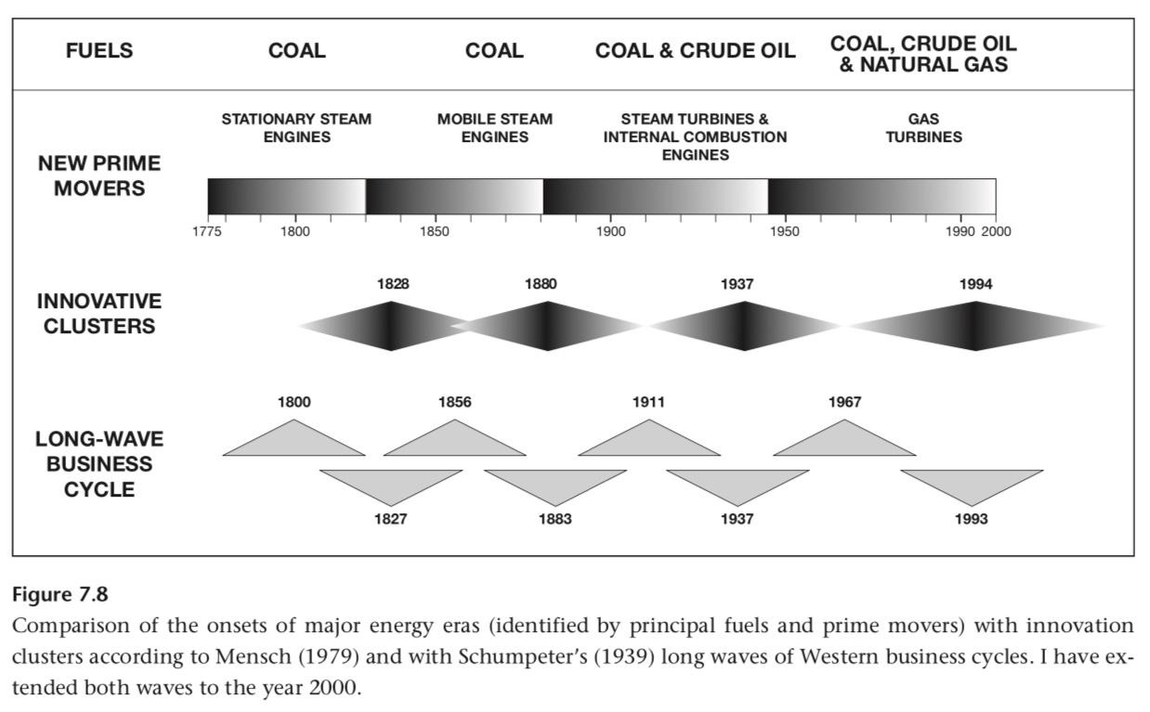

Another application of societal cycles. Still skeptical.

Taking into account the time required to buy a car, they move at 5-8 km/h

“But as soon as our mastery of the physical world began to yield modest energy surpluses, human ingenuity used them to create a man-made world
of diversity and (for some) leisure, even though more energy could be used to secure basic physical needs.“

“A weight-bearing column could be just asimple smooth stone cylinder or an elongated prism; there was never any structural or functional need for the three orders of ancient Greek architecture (the Doric, Ionic, and Corinthian).”

Best Lamborghinis or Mercedes Benz’s have 1.176 MW. 1600 hp.

Such plenty we live in with 100 records of a single Vivaldi piece.

“On a more mundane level, tens of millions of people annually take intercontinental flights to generic beaches in order to acquire skin cancer faster; the shrinking cohort of classical music aficionados has more than 100 recordings of Vivaldi’s Quattro Stagioni to choose from; there are more than 500 varieties of breakfast cereals and more than 700 models of passenger cars.“

Be careful how you generalize:

“To generalize, across millennia, that higher socioeconomic complexity requires higher and more efficiently used inputs of energy is to describe indisputable reality. To conclude that every refinement of energy flows brought a refinement in cultural mechanisms, as Fox (1988) did, is to ignore a mass of contradictory historical evidence.”

“Energy conversion is always necessary to get anything accomplished, but none of the extrasomatic conversions initiated and controlled by people is predestined, and only a few of them arise simply from chaos or accident. This dichotomy is as important for interpreting the past as it is for understanding future possibilities: they too are not predestined, but their scope is definitely restricted, and energy flows impose the most fundamental limits.”

Grasslands and woodlands preferable to dense forests for early humans.

Total amount of edible biomass and ease of accessibility was more import than variety.

Lipids provide satiety.

Circles

Egypt to Rome could take 1-12 weeks. Again, circles.

1588 the Spanish Armada attempted and failed to land in England due to wind. Ok this is a fun anecdote, like the one I used the in learning rate blog.

Peat ushered in Dutch’s golden age in the 17th century.

“Undoubtedly, the successive positions of economic leadership and international influence of the Dutch Republic, Great Britain, and the United States have been closely related to their early exploitation of fuels extractable with a smaller amount of investment per unit of useful energy (that is, with a higher net energy return).”

If we were to revert to draft animals now, we’d need 10x the peak in the US.

“As we recover higher shares of originally available resources, the best measure of their availability is the cost of producing a marginal unit of a mineral. This approach takes into account improvements in our exploitation techniques and our ability to pay the price of recovery.”

Eg. Shale oil in the US

“there are no sudden ends, only prolonged declines, slow exits, and gradual shifts onto new supply planes.”

Good quotes on the end of fossil fuels here.

“That fossil fuel resources are finite does not imply
any fixed dates for the physical exhaustion of coals or hydrocarbons, nor does it mean the early onset of unbearably rising real costs of recovering these resources and hence the necessity of a rapid transition to a post–fossil fuel era.”

What it takes to control a prime mover:
This is what is meant by power controls.

“No matter how strong and capable, a horse becomes an effectively controlled prime mover only when a bit is inserted in its mouth and connected to reins held in a rider’s hand.”

Also, not determini longitude at sea is an example of poor power control!!

You need to find new uses of new fuels:

“As far as fuels are concerned, history would have taken a different course if coal had been used merely as a substitute for wood in open fireplaces, or if crude oil use had remained limited to kerosene for lighting.”

Ok now the book is getting to insights instead of a barrage of information.

“In most cases it has not been the access to abundant energy resources or to particular prime movers that made the long-term difference. Decisive factors were rather the quest for innovation and the commitment to deploying and perfecting new resources and techniques and finding new uses.“

Most improtant class of controls was feedback devices and systems. Eg. Thermostat (1620) fantails on windmills (1745), Watt’s centrifugal governor (1789).

This is where Europe led, feedback systems ftw!!!

Punched cards were first used in looms in the 1800s.

The largest scale control system is how a society proportions energy. Eg. Autarky or global trade? Personal or industrial use?

“A comparison of Russia’s and Japan’s post-1945 economic fortunes contrasts quantity versus quality, autarchy versus commerce, and the role of the state as the sole arbiter versus the state as the leading catalyst of modernization.”

Japan was an energy importer. It became a high efficiency user of energy.

The Soviet Union was self sufficient in energy and exported fuels.

However, they were the least efficient user of energy in the industrialised world.

Interesting adjective, USSR was Autarchic:
“autarchic Stalinist five-year plans.”

McNeill (1980):
Micro parasites are classified as bugs that destroy harvests, etc. Bacteria, fungi, insects.

Macro parasites are social control on energy flows.

“Macroparasitism has assumed a variety of social controls of energy flows relying both on coercion—ranging from slavery and corvée labor to military conquest—and on complex (and partly voluntary) relationships among unequal groups of people.”

Eg. Special interest groups, most improtant macroparasitic groups in western societies.

Eg. “professional associations and labor unions with restricted entries to oligopolistic industrial cartels and lobbies.”

Macro parasites are behind subsidies:

“They have been behind the heavy subsidies that for decades have gone to producers of various fossil fuels and nuclear electricity, and now they are behind the new subsidies promoting the construction of solar photovoltaics and wind turbines”

Again, be careful with the direction of causality:
Organisms determine how energy flows, not the opposite.

“Energy flows do not provide an explanation for why there are organisms, why organisms vary, or why there are different species. … It is an organism’s intrinsic properties that determine how energy will flow, not the opposite. If the flow of energy were deterministic for biological systems, it would be impossible for anything living to starve to death. … We suggest that organisms are physical systems with genetically and epigenetically determined individual characteristics, which utilize energy that is flowing through the environment in a relatively stochastic manner.”
- Brooks and Wiley (1986, 37–38)

Don’t buy into energetic determinism? It’s an enabling factor for more!!!! It sets the limits! Build higher limits!

“But such energetic determinism, like any other reductionist explanation, is highly misleading.”

Greeks treated slaves like draft animals, but also gave us democracy:

“The Greeks of the classical era often referred to their slaves in terms clearly placing them on the level of working animals (calling them andrapoda, man-footed, as opposed to cattle, tetrapoda)—but they gave us the fundamental ideas of individual freedom and democracy.”

“No energetic considerations can explain the presence of Gluck, Haydn, and Mozart in the same room in Joseph II’s Vienna of the 1780s.”

Again, energy flows set the limits and a broad trend, but are not deterministic:
Maybe there’s a blog post in this.

“Very similar per capita energy use (for example, that of Russia and New Zealand) can produce fundamentally different outcomes, while highly disparate energy consumption rates have resulted in surprisingly similar levels of physical quality of life: South Korea and Israel have nearly identical human development index while the Korean per capita energy use is about 80% higher.“

Imperial Overstretch Syndrome:

“The most notable energy-related explanations have included the effects of widespread ecosystemic degradation brought about by unsustainable methods of farming and by excessive deforestation and resulting in reduced food production. The impossibility of effectively integrating large empires because of poor land transportation and the rising burden of resources to protect distant territories (the imperial overstretch syndrome) are other common explanations.”

Fall of Rome:
“explanations favoring social dysfunction, internal conflict, invasions, epidemics, or climatic change are much more common.”

What can’t be attributed to prime movers and fuels:
Romans Republic, Islam in the seventh century, Mongolian invasions of the 13th century.

“note the coexistence of two contradictory expectations concerning the energy basis of modern society: chronic conservatism (lack of imagination?) regarding the power of technical innovation, set against repeatedly exaggerated claims made on behalf of new energy sources.”

Lord Kelvin on flight:

“In 1896 Lord Kelvin refused to join the Royal Aeronautical Society: his hard written note to Baden F.S. Baden-Powell, an enthusiastic military aviation proponent, said that he had “not the smallest molecule of faith in aerial navigation other than ballooning” (Thomson 1896).”

“After millennia of reliance on biomass fuels, many nineteenth-century writers saw coal as an ideal energy source and the steam engine as a nearly miraculous prime mover.”

“Social cohesion and family nurturing so characteristic of rural life clearly do not prevail in modern cities.”

Lenin on electricity:
“Even before the end of the Russian Civil War, Lenin (1920, 1) concluded that economic success “can be assured only when the Russian proletarian state effectively controls a huge industrial machine built on up-to-day technology; that means electrification.””

TOO CHEAP TO METER - LEWIS L. STRAUSS

“Our children will enjoy in their homes electrical energy too cheap to meter. It is not too much to expect that our children will know of great periodic regional famines in the world only as matters of history, will travel effortlessly over the seas and under them and through the air with a minimum of danger and at great speeds, and will experience a lifespan far longer than ours, as disease yields and man comes to understand what causes him to age. This is the forecast of an age of peace. (Strauss 1954, 5).”

He’s very pessimistic on fusion too, saying no progress has been made in a decade:

“And then there is, as there has been ever since 1945, the ultimate promise of electricity from nuclear fusion (although in practical terms we are no closer to that goal now than we were a generation ago).”

He doesn’t believe in Lotka’s law of maximum energy:

Lotka’s law of maximum energy:
“natural selection favors organisms that can capture and utilize the most energy, leading to a selective advantage in the evolutionary process.”

The USSR imported grain? Tsarist Russia exported??

“wood-burning czarist Russia was a grain exporter; the USSR, the hydrocarbon superpower, had to import grain.”

Another indictment of energy progress being a sole driver of progress. It raises the limit!

“Our current energy system is self-limiting: even on a historical time scale our high-energy civilization, exploiting the accumulated store of ancient radiation transformed into fuels, is just an interlude because even if the combustion of those fuels had no environmental impacts it could not, unlike its predecessors, based on harvesting near-instant solar energy flows, last for millennia.”

Full Antarctic ice sheet melting would mean sea level rise of 58m.

Terraform solves this.

We’ll green new worlds.

“In contrast, techno-optimists see a future of unlimited energy, whether from super efficient PV cells or from nuclear fusion, and of humanity colonizing other planets suitably terraformed to the Earth’s image. For the foreseeable future (two-four generations, 50–100 years) I see such expansive visions as nothing but fairy tales.”

